A Study on the Construction and Communication Effectiveness of the Digital Narrative System for the ‘Comprehensive Ideological and Political Education Course’ in the Context of Omnichannel Media
Xingchen Zhao
Jiaxing University, Zhejiang Province, China
Email address:wusaqi@zjxu.edu.cn
Abstract: The transformation of the communication ecosystem in the era of omni-media presents a crucial opportunity for the digital transformation of ideological and political education, yet it also poses a serious challenge to the appeal of traditional ideological and political courses and their ability to retain audiences. Addressing the practical difficulties faced by the 'comprehensive ideological and political education'—such as weakened narrative power and insufficient emotional resonance amidst fragmented information flows—this study deconstructs the intrinsic coupling mechanism between digital storytelling and the 'comprehensive ideological and political education'. By focusing on four dimensions—content reconstruction, structural arrangement, discourse transformation, and technological integration—it establishes a digital narrative framework that is all-encompassing across participants, time, and scope. Building upon this, we evaluate its communicative efficacy across four dimensions—coverage breadth, cognitive depth, emotional intensity, and behavioural conversion—to reveal the driving role of digital narrative in strengthening identification with mainstream values and enhancing the Effectiveness of education. This provides a theoretical reference for promoting the high-quality integrated development of ideological and political education in the new era.
Keywords: “Grand Ideological and Political Education Course”; digital narrative; system construction; communicative efficacy

Introduction
Against the broader backdrop of an all-media environment deeply embedded in every sphere of social life, the information ecosystem, discursive space, and audience behaviour patterns in ideological and political education are undergoing a fundamental paradigm shift. With the iterative evolution of information technology and media platforms, the traditional teaching model of ideological and political education—which relies on a single classroom space, linear textbook logic, and a one-way indoctrination mechanism—is no longer fully suited to the fragmented consumption habits and awakening sense of agency of audiences in the digital age^{[1]}. Currently, the development of the 'comprehensive ideological and political education programme' is regarded as a key pathway to fulfilling the fundamental task of fostering virtue through education. This approach emphasises the deep integration of educational resources with social realities and technological media, striving to establish an educational framework that is ubiquitous across time and space and characterised by synergy between educators and learners. However, in actual teaching practice, bottlenecks persist, such as a one-dimensional narrative, a disconnect between theoretical discourse and the logic of everyday life, and the superficial application of digital technology. Consequently, the Effectiveness of mainstream ideology's dissemination within the online public sphere faces severe challenges. How to utilise digital narrative—this new mode of expression—to systematically reshape the content provision, structural arrangement, and discursive expression of ideological and political education has become a core proposition for promoting the high-quality development of such education in the new era. By constructing a scientific and comprehensive digital narrative system, we can effectively respond to the practical demands of technology-enabled education and, by enhancing emotional resonance and value identification among the audience, achieve a logical leap in ideological and political education from physical engagement to spiritual resonance.

1 Overview

1.1 Digital Narrative
As a product of the deep integration of narratology and digital technology in the era of all-media, digital storytelling is fundamentally based on the digital reconstruction of the semantic space through multimodal sign systems^{[2]}. In an academic context, digital storytelling is a dynamic representational paradigm constructed upon interactive technologies, hypertext structures, and virtual simulation environments. Its essential characteristics are manifested in the decentralisation of the narrative subject and the non-linearity of the narrative process; through the embedding of technological media, the audience is transformed from mere recipients of information into participants and co-creators within the narrative context. Relying on digital encoding technology, digital storytelling achieves the organic integration of diverse symbolic resources—including text, images, audio, and video—to form a form of communication characterised by a high degree of immersion and interactivity^{[3]}. Within this system, narrative logic, through hyperlinks and algorithmic recommendation mechanisms, reorganises logical connections within fragmented information flows, thereby achieving a deep alignment between mainstream values and individual cognition.

1.2 The 'Comprehensive Ideological and Political Education Course.'
The Outline of the Plan for Building a Powerhouse in Education (2024–2035) proposes 'implementing the national strategy for the digitalisation of education', 'promoting the use of artificial intelligence to drive educational reform', and 'advancing the deep integration of ideological and political work with information technology'. In light of these new requirements, we must advance the development of the "Comprehensive Ideological and Political Education Programme" in a manner that keeps pace with the times, innovates teaching methods and approaches, and thoroughly understands and effectively addresses fundamental questions such as why this programme is comprehensive and how it can be utilised effectively. The "Comprehensive Ideological and Political Education Programme" represents a reshaping of the educational ecosystem, emphasising the organic integration of the small classroom of ideological and political education with the broader classroom of society, thereby facilitating a profound unification of theoretical and practical logic within real-world contexts. Its essence is primarily woven from four core dimensions: a grand vision, distinguished educators, a comprehensive platform, and significant achievements (Table 1). This educational paradigm requires the teaching process to transcend mere knowledge transmission and instead focus on the internalisation and identification with value-led guidance within complex social contexts. Through the integration of physical, digital, and social spaces, the 'Grand Ideological and Political Education Course' constructs a ubiquitous educational field, providing broader career support and practical guidance for disseminating mainstream ideology, thereby embodying the openness and systematic nature of ideological and political education in the era of all-media.
Table 1: What Makes the 'Comprehensive Ideological and Political Education Course' Comprehensive?
Core Dimensions | Academic Essence | Digital representation | Educational Objectives
Broad Vision | Macro-political perspective and strategic orientation | Coordination of ideological platforms across all media channels | Nurturing character and shaping the next generation
Distinguished Leader | A diverse, cross-disciplinary faculty | Hybrid online and offline mentoring teams | Uniting efforts and reinforcing value-based guidance
Major Platform | Blended learning environments and platforms | Virtual simulation and big data interaction platforms | Fostering intelligent interaction and achieving resource sharing
Significant Achievements | In-depth integration of theory and social practice | Closed-loop digital management and effectiveness evaluation | Integrating knowledge with practice to enhance the Effectiveness of education

2. Building a Digital Narrative Framework for the ‘Comprehensive Ideological and Political Education Course’ in the Context of Omnichannel Media

2.1 The Narrative Content Layer
The narrative content layer involves the micro-level treatment of grand themes through digital technology, generating meaning from fragmented resources via systematic integration. Its primary logic lies in the digital transcoding of contemporary archetypes, historical archives, and materials from social practice, thereby facilitating a shift from theoretical discourse to narrative discourse^{[4]}. The content layer should strike a balance between the lofty standards of political guidance and the immediacy of everyday life, employing multimodal symbols to present the practice of socialism with Chinese characteristics from every angle. Digital methods drive content production to prioritise the real-time updating and dynamic generation of narrative materials; by unearthing authentic case studies imbued with emotional resonance and value-driven tension, knowledge graphs with strong explanatory power can be created. This content production paradigm requires educators, whilst maintaining theoretical rigour, to enhance the narrative quality and logical coherence of content, embedding abstract value concepts within concrete digital texts. Through the systematic development of the content layer, a solid foundation of material can be provided for subsequent structural organisation and technical distribution, ensuring that the ‘Grand Ideological and Political Education Course’ maintains its competitive edge and capacity for value leadership amidst a vast sea of digital information, thereby achieving a leap from the transmission of knowledge to the construction of meaning.

2.2 Narrative Structural Layer
In an omni-media context, the narrative structure of the 'comprehensive ideological and political education course' should shift from the original linear, unidirectional logic to a multidimensional, composite network structure. The core of this structural reformation lies in establishing a curatorial model that integrates modular design with associative reorganisation, breaking complex theoretical knowledge into narrative units that possess independent meaning while remaining interconnected (Figure 1). The construction of the structural layer emphasises the use of non-linear narration. By utilising hyperlink technology, interactive scripts and temporal inversion, it breaks the continuity of physical teaching time, granting the audience the right to select narrative pathways autonomously. At the same time, the digital narrative structure must also ensure coordination between the macro-narrative context and micro-narrative entry points. By establishing interactive touchpoints at different narrative nodes, it achieves logical coherence through participatory deconstruction and reconstruction of information. The requirement for multi-terminal coordination across an omnichannel platform demands that the structural layer possess exceptional adaptability, enabling ideological and political narratives to maintain the integrity of their logical chains and control over narrative pacing across different media terminals, whilst establishing a robust theoretical framework and semantic architecture even amidst a complex flow of information.
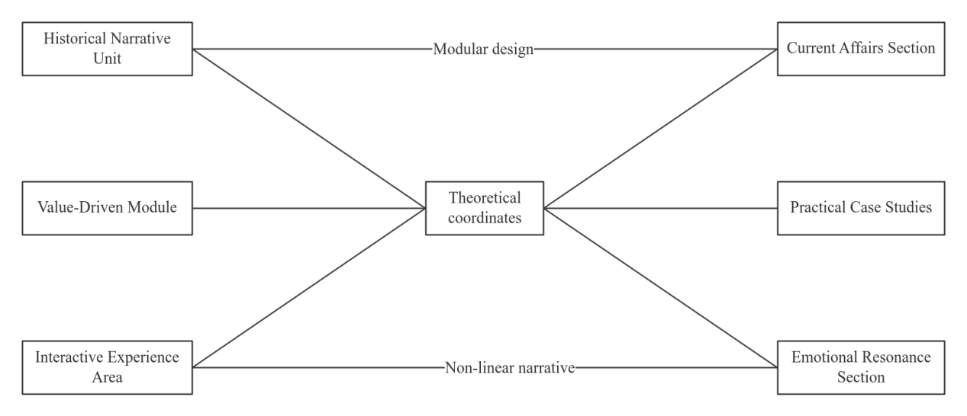
Fig. 1 Narrative Structure Layer

2.3 The Narrative Discourse Layer
The narrative discourse layer serves as the mediating force within the digital narrative system, facilitating the transmission of values and the translation of meaning; its primary task is to transform political and academic discourse into the discourse of digital life. In an omnichannel context, the construction of the 'Grand Ideological and Political Education Course' discourse must move away from the traditional, didactic approach of piling up words, and instead adopt modes of expression that are more interactive, empathetic, and symbolic^{[5]}. This discursive transformation constitutes a digital reconstruction of mainstream values, grounded in principles of communication studies, emphasising the use of visual rhetoric, auditory metaphors, and socially mediated linguistic logic to enhance the discourse's penetrative power. During this construction process, the discursive layer must prioritise the synergistic effects of multimodal symbols, embedding grand theories within easily decodable symbolic sequences through means such as memorable quotes in short videos, interactive comment streams, and dialogues in virtual scenarios. Furthermore, the generative logic of digital discourse requires educators to delegate discursive authority, allowing audiences to freely participate in the creation of discourse within the digital space, and to achieve a fission of meaning through evaluation, sharing, and secondary construction. This open discursive environment can bridge the psychological distance between educational providers and the audience. Under the logic of algorithmic recommendations and social media distribution, ideological and political discourse gains greater communicative power and interpretative authority, thereby establishing the leadership of mainstream ideology within the digital sphere, where diverse values coexist.

2.4 Narrative Technology Layer
The Narrative Technology Layer serves as the underlying architecture and driving force supporting the operation of the 'Grand Ideological and Political Education Course' digital narrative system. Its primary function is to provide an immersive medium for content presentation, structural layout, and discursive interaction. The Technology Layer is not merely a collection of tools; it utilises cutting-edge technologies such as artificial intelligence, virtual and augmented reality, and big data algorithms to achieve a fundamental shift in the narrative space from 'two-dimensional flatness' to 'multidimensional embodiment' (Figure 2). The focus of the technical layer lies in creating a digital teaching platform that blends the virtual and the real. It recreates historical scenes through high-performance rendering technology. It enhances the audience's sense of presence through sensor-based interaction technology, thereby breaking through the constraints of time and space from a sensory perspective. At the technical level, algorithmic logic plays a role in precise distribution and feedback capture; it monitors and performs real-time cluster analysis of audience behaviour data, dynamically adjusting the rhythm and path of the narrative to deliver personalised ideological and political education resources. Furthermore, high-speed communication technologies such as 5G enable various multimodal narrative resources to be rapidly transmitted to individual terminals and synchronised across multiple devices. This technology-mediated narrative environment enhances information capacity and expressiveness, providing the necessary technical support and a closed-loop ecosystem for high-quality, intelligent 'comprehensive ideological and political education' teaching.
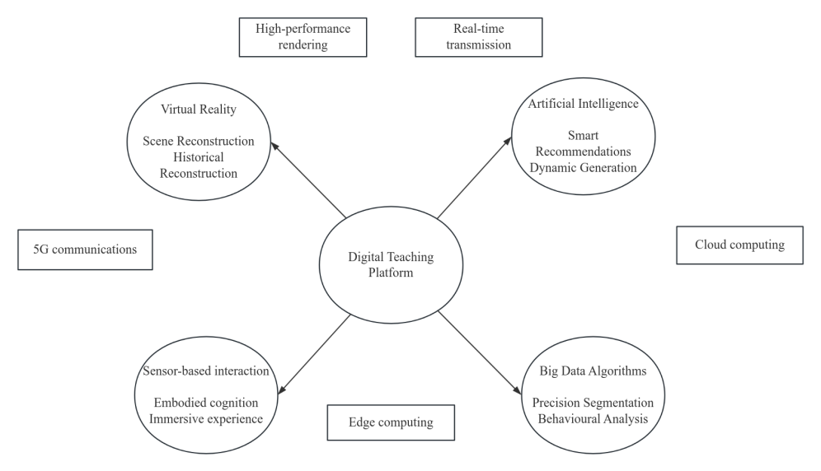
Fig. 2 Narrative Technology Layer

3 The Communication Effectiveness of the Digital Narrative System for the ‘Comprehensive Ideological and Political Education Course’ in the Context of Omnichannel Media

3.1 Reach Effectiveness
In the context of an all-media environment, digital storytelling deconstructs the physical boundaries of traditional classrooms, enabling the flow of ideological and political education resources from localised settings to a wider digital landscape. The underlying logic relies on mobile internet, social networks, and various digital devices to form a ubiquitous information distribution network, enabling mainstream values to permeate the audience's daily lives. The enhanced coverage is not merely a matter of physical user reach, but also the precise targeting enabled by algorithmic logic. Through tag-based matching and personalised push notifications, digital storytelling can break free from the constraints of information silos and establish public opinion platforms for ideological and political education across various digital platforms^{[6]}. Furthermore, the high reusability and instantaneous dissemination capabilities of digital systems enable high-quality narrative materials to overcome geographical constraints, thereby achieving the objectives of educational equity and the balanced distribution of resources. This broad-spectrum dissemination model provides a technological dividend for the 'Grand Ideological and Political Education Course' as it transitions from small-scale pilot schemes to large-scale education, laying the foundation for quantifying cognitive guidance and emotional identification.

3.2 Cognitive Effectiveness
Cognitive Effectiveness is an indicator used to measure the extent to which the digital narrative system of the 'Comprehensive Ideological and Political Education Course' facilitates information encoding, decoding, and theoretical internalisation among its audience. In an omni-media context, digital storytelling significantly enhances the dissemination and comprehension of ideological and political theories through its multimodal symbolic systems and interactive logic. Its fundamental logic lies in transforming abstract and grand theoretical discourses into concrete and vivid narrative texts through the combined influence of various media—including text and images, audio and video, animations, and virtual simulations—thereby effectively reducing the audience's information processing burden and cognitive threshold. Digital storytelling breaks through the one-way knowledge transmission methods of traditional ideological and political courses, creating a non-linear, networked knowledge map that leaves space for the audience to explore and construct meaning autonomously. This participatory cognitive process facilitates the audience's deep-level decoding and restructuring of core values, strengthening their ability to analyse complex social phenomena and to synthesise theory within a digital environment. Furthermore, through the integration of big data and algorithmic technologies, the digital narrative system continuously adjusts content delivery and narrative pacing based on the audience's cognitive preferences and feedback behaviours, shifting from 'blanket dissemination' to 'targeted delivery', thereby effectively facilitating the audience's transition from emotional experience to rational understanding.

3.3 Emotional Efficacy
Emotional efficacy refers to the capacity of digital narratives to evoke emotional responses in audiences, foster resonance, and promote value alignment. In an omni-media context, digital narratives leverage their embodied communication characteristics and technologies to render context and transform the traditional function of logical persuasion into the contemporary power of emotional engagement. The primary logic lies in reconstructing the spatial relationship between the audience and the narrative object through immersive means such as virtual reality and augmented reality, transforming the audience from bystanders into on-site participants in historical scenes or social practices. The creation of a sense of presence activates the audience's empathy mechanisms; when various audiovisual symbols work in concert, this generates intense emotional shifts and psychological identification. Digital storytelling deeply interweaves individual experiences with grand narratives, transforming abstract ideological orientations into concrete, tangible emotional narratives that can evoke empathy. This, in turn, reduces the audience's psychological defences against the transmission of mainstream values. Furthermore, digital interactive mechanisms provide the audience with channels for emotional expression and response. Through social evaluation, sharing, and co-creation processes, individual emotions coalesce within social networks and transform into collective consensus, thereby reinforcing the stability of emotional identification. This enhanced emotional efficacy renders the 'Grand Ideological and Political Education Course' more compelling. Driven by emotional mechanisms, it lays the psychological foundation for transforming value concepts from short-term cognition into long-term internalisation, thereby ensuring the emotional penetrative power of ideological and political education in the digital age.

3.4 Transformative Effectiveness
Transformative Effectiveness serves as the ultimate indicator of the 'Grand Ideological and Political Education Course' digital narrative system's ultimate objective. It is manifested in the extent to which audiences, building upon deepened understanding and emotional resonance, translate mainstream values into concrete social practices through behavioural change. In an omni-media context, digital narratives, through their inherent interactivity, situational simulation, and community effects, achieve the objectives of effective information transmission and deep emotional resonance, whilst shaping a mechanism for transformation from virtual identification to real-world action. The core mechanism lies in utilising digital technology to create a practical environment that blends the virtual and the real. Through formats such as serious games, virtual simulation experiments, and online community tasks, it provides audiences with low-cost, highly immersive social role-playing experiences and moral dilemma scenarios. This embodied virtual practice effectively links individual life experiences with grand narratives, allowing theoretical logic to be internalised through decision-making and interaction. Furthermore, the characteristics of omnichannel platforms—such as instant feedback and group incentives—form a positive psychological reinforcement loop through the visualisation of individual positive behaviour and social 'likes', prompting audiences to transform their ideals and convictions into conscious action.

Conclusion
The establishment of a digital narrative system for the 'comprehensive ideological and political education programme' within the context of an all-media environment represents an inevitable choice for ideological and political education in responding to technological innovation and the demands of the times. Through in-depth analysis and systematic reconstruction from the perspectives of content, structure, discourse, and technology, digital narrative has broken through the temporal and spatial constraints of traditional ideological and political education, significantly enhancing communication effectiveness in terms of coverage, cognitive engagement, emotional resonance, and behavioural transformation. In the future, efforts should continue to strengthen the ethical application of cutting-edge technologies, such as artificial intelligence, within the narrative framework, whilst continuously refining the effectiveness evaluation system. This will ensure that the 'Comprehensive Ideological and Political Education Course' remains steadfastly committed to the core principle of fostering virtue and nurturing talent amidst the digital wave, thereby achieving a leap forward in the Effectiveness of its educational outcomes.

References
[1]Ho C E. Negotiating local identities for a global audience: A chronotopic approach to stance-taking analysis in transnational educational digital storytelling[J].Linguistics and Education,2026,92101512-101512.
[2]Ángel O A J, Devia S A Á, Gonzalez B C D. Transmedia digital narratives in mathematics teaching in educational contexts: a systematic, bibliometric, and structural review (2014–2024)[J].Frontiers in Education,2026,101719806-1719806.
[3]Fan Q. Digital Empowerment of the "Great Ideological and Political Course": An Innovative Path to Promote the Development of New Quality Productivity[J]—International Journal of New Developments in Education,2025,7(12).
[4]Zhang Y. Exploration of Practical Teaching Bottlenecks and Collaborative Mechanisms in the “Great Ideological and Political Course”[J].Contemporary Education Frontiers,2025,3(8):171-176.
[5]Wu X. An Exploration of Three Dimensions in Promoting the Construction of "Great Ideological and Political Course" with Emotional Education Wisdom -- An Interpretation Based on How to Cultivate a Truly Good Person[J].New Explorations in Education and Teaching,2025,3(8).
[6]Xuelin L. Application and Strategy of AIGC in Omnimedia Knowledge Dissemination Under the Background of Digital Empowerment[J].International Journal of Knowledge Management (IJKM), 2025, 21 (1): 1-16.

