Data-Driven Decision-Making under Humanitarian Uncertainty
Author Information:
First author
1. Author's name: ChunXia Yang
2. Unit Information: People's Public Security University of China
3. Education: Ph.D.
4. Article Position: First Author
5. Institutional Email (Educational Email) ChunXia Yang,
Email: AdaptiveLearn@163.com

5. Contact Address: People's Public Security University of China, Muxidinanli Road, No. 1, Xicheng District, Beijing, 100038, Beijing, China
7. Title: Lecturer
8. Fund Project
9. Self-introduction (100–150 words), which should include full name, current affiliation, position, research interests, and key achievements or publications
ChunXia Yang was born in Yuci, Shanxi, China in 1978. She obtained a doctor's degree from Renmin University in China. She is currently working at the School of International Policing, People's Public Security University. Her main research field is International Relations and Immigration Management.

Corresponding Author:
Lulu Yang
Beijing Language and Culture University, Beijing, China
yanglulu202603@163.com
Beijing Language and Culture University, No. 15 Xueyuan Road, Haidian District, Beijing 100083, P.R. China
Abstract
International organizations such as the United Nations (UN) face increasing pressure to make timely and evidence-based decisions in complex humanitarian crises, where traditional decision-making mechanisms are often constrained by information delays, fragmented data sources, and limited predictive capacity. Drawing on the information-processing perspective of organizational decision-making, this study examines how Big Data Analytics (BDA) can enhance decision-making effectiveness in international humanitarian operations. Using a mixed-methods research design, the study integrates primary data collected from UN stakeholders with large-scale secondary data from the UNHCR refugee dataset. A comprehensive BDA framework is developed that combines descriptive, predictive, and prescriptive analytics to support real-time crisis assessment and resource allocation. Empirical results from exploratory and predictive analyses reveal strong associations between crisis intensity and refugee movements, and the proposed predictive model explains 78.7% of the variance in decision-making outcomes. The findings demonstrate that BDA-enabled analytics significantly improve information quality, forecasting accuracy, and resource allocation efficiency in humanitarian contexts. This study contributes to the literature on data-driven decision-making in international organizations by providing empirical evidence on the role of BDA in enhancing humanitarian governance, while offering practical insights for strengthening real-time decision support systems in global crisis response.
Keywords: Big Data Analytics; Organizational Decision-Making; Information Processing; Humanitarian Governance; Crisis Response; Resource Allocation.
1.Introduction
In recent years, international organizations have faced unprecedented challenges arising from humanitarian disasters, climate change, armed conflicts, and large-scale forced displacement. These complex and rapidly evolving crises require timely, accurate, and evidence-based decision-making, particularly in high-risk areas such as refugee assistance, emergency relief, and humanitarian resource allocation (Podgórska et al., 2024; Barakat et al., 2023). However, existing decision-making practices in international humanitarian governance often remain constrained by fragmented information systems, delayed data processing, and a heavy reliance on retrospective data, which limits organizations' ability to respond effectively to dynamic crisis environments (Elgendy et al., 2022; Hassani & MacFeely, 2023).
Recent scholarship on organizational decision-making emphasizes that decision quality under conditions of uncertainty increasingly depends on an organization’s capacity to integrate heterogeneous data sources, enhance information quality, and support rapid analytical interpretation (Niu et al., 2021; Ragazou et al., 2023). In humanitarian contexts, where crisis dynamics change quickly and operational consequences are substantial, data-driven decision-making has become central to improving responsiveness, coordination, and resource efficiency (Francisco & Linnér, 2023). Nevertheless, traditional decision-making approaches in international organizations are still largely grounded in historical records and professional judgment, which are often insufficient for anticipating emerging risks or guiding real-time interventions during humanitarian emergencies (Barakat et al., 2023).
Advances in Big Data Analytics (BDA) provide new opportunities to address these limitations by strengthening organizational analytical and information-processing capabilities. BDA enables the collection, integration, and real-time analysis of large-scale and diverse data sources, thereby improving situational awareness, forecasting accuracy, and decision responsiveness (Ikegwu et al., 2022; Hassani & MacFeely, 2023). Within the humanitarian governance literature, BDA has been increasingly recognized for its potential to support crisis monitoring, refugee flow forecasting, and evidence-based resource allocation through the combined use of descriptive, predictive, and prescriptive analytics (Sharma et al., 2022). Descriptive analytics facilitate the understanding of historical patterns, predictive analytics anticipate future developments, and prescriptive analytics generate data-driven recommendations for optimal decision outcomes.
Despite this growing interest, existing research exhibits several important limitations. First, much of the literature focuses on technical or conceptual discussions of analytics tools, while offering limited empirical evidence on how BDA enhances decision-making effectiveness in real-world humanitarian operations. Second, prior studies often examine individual analytical techniques in isolation, rather than considering the integrative value of combining descriptive, predictive, and prescriptive analytics within a unified decision-support framework (Ragazou et al., 2023). Third, empirical studies that systematically investigate data-driven decision-making in international organizations using large-scale humanitarian data remain relatively scarce, leaving a gap between analytical potential and practical governance applications.
To address these gaps, this study develops and empirically evaluates an integrated Big Data Analytics framework for enhancing decision-making effectiveness in international humanitarian organizations, with a particular focus on refugee crisis governance. Drawing on recent advances in data-driven decision-making research, the proposed framework illustrates how the integration of descriptive, predictive, and prescriptive analytics improves information quality, forecasting capacity, and resource allocation efficiency under conditions of uncertainty. Using a mixed-methods research design, this study combines qualitative insights from stakeholders within international organizations with large-scale quantitative evidence derived from the UNHCR refugee dataset to examine the practical value of BDA-enabled decision support.
This study makes three primary contributions. First, it extends the literature on data-driven organizational decision-making by providing empirical evidence on the role of Big Data Analytics in improving decision quality within international humanitarian contexts. Second, it proposes an integrated analytical framework that moves beyond isolated analytical techniques and demonstrates the complementary value of descriptive, predictive, and prescriptive analytics for real-time crisis response. Third, it offers policy-relevant insights for international organizations seeking to strengthen evidence-based decision-making and operational resilience in the face of increasingly complex and volatile global crises.
The remainder of this paper is structured as follows. Section 2 reviews the relevant literature on Big Data Analytics and organizational decision-making. Section 3 presents the research design, data sources, and methodological approach. Section 4 reports and discusses the empirical findings. Section 5 concludes with implications for theory, policy, and future research.
2. Literature Review
2.1 Existing Studies on Big Data Analytics and Data-Driven Governance
Recent studies have increasingly emphasized the role of Big Data Analytics (BDA) in enhancing data-driven governance and organizational decision-making across public and international institutions. Hassani and MacFeely (2023) highlight that the rapid expansion of digital data sources has fundamentally reshaped how organizations collect, manage, and govern information, while simultaneously raising challenges related to data quality, transparency, and accountability. Their work underscores the importance of robust data governance frameworks to ensure that analytical outputs remain reliable, interpretable, and ethically grounded.
From a global governance perspective, Francisco and Linnér (2023) examine how artificial intelligence and data-driven technologies are embedded within international policy frameworks, particularly in relation to sustainable development. Their findings suggest that data-driven governance has become central to policy formulation in areas such as environmental sustainability, humanitarian assistance, and social development, while also intensifying concerns related to ethics, human rights, cybersecurity, and the digital divide.
Beyond governance frameworks, empirical research has documented the expanding application of data-driven approaches across diverse policy domains. Guo et al. (2022) demonstrate that big data plays a critical role in monitoring progress toward the Sustainable Development Goals (SDGs), especially through the integration of multi-source datasets for environmental, urban, and climate-related assessments. Similarly, Ragazou et al. (2023) provide a comprehensive bibliometric analysis showing that BDA has become a key driver of organizational competitiveness and decision effectiveness, with growing scholarly attention across management, information systems, and public administration.
Collectively, this body of literature establishes BDA as a foundational component of contemporary data-driven governance, highlighting its capacity to enhance transparency, coordination, and strategic decision-making in complex organizational settings.
2.2 Mechanisms Linking Big Data Analytics to Decision-Making Processes
A growing stream of research has sought to explain how BDA influences organizational decision-making by identifying the underlying mechanisms through which analytical capabilities translate into improved decisions. One dominant mechanism emphasized in recent studies is the enhancement of information quality. By integrating heterogeneous and real-time data sources, BDA improves data accuracy, timeliness, and completeness, thereby reducing informational uncertainty in decision environments (Ikegwu et al., 2022; Hassani & MacFeely, 2023).
Another key mechanism relates to predictive and anticipatory capacity. Advances in machine learning and advanced analytics enable organizations to move beyond descriptive assessments toward forecasting future trends and identifying emerging risks. For instance, Nanehkaran et al. (2023) demonstrate how machine learning models significantly improve hazard prediction accuracy in disaster risk management, enabling earlier and more targeted interventions. Similar mechanisms are observed in urban governance and tourism management, where crowdsourced and real-time data support more adaptive and responsive decision-making processes (Liu et al., 2023).
Prescriptive analytics further strengthens decision-making by translating predictive insights into actionable recommendations. Rather than merely identifying potential outcomes, prescriptive models support optimal resource allocation and policy choices under multiple constraints. Sharma et al. (2022) argue that the integration of descriptive, predictive, and prescriptive analytics forms a comprehensive decision-support architecture that enhances organizational responsiveness and coordination, particularly in dynamic and high-risk environments.
Together, these studies suggest that BDA improves decision-making through interconnected mechanisms involving information quality enhancement, predictive capacity, and optimization-oriented decision support.
2.3 Outcomes of Big Data Analytics in Organizational and Humanitarian Contexts
Empirical research has increasingly documented the outcomes associated with the adoption of BDA in organizational and public-sector contexts. One prominent outcome is improved operational efficiency and resource allocation. Studies in environmental monitoring and infrastructure management show that data-driven systems enable more efficient use of resources by aligning interventions with real-time conditions and projected needs (Mukonza & Chiang, 2023; Argyroudis et al., 2022).
In humanitarian and crisis-response settings, BDA has been linked to enhanced coordination and resilience. Ülkü et al. (2024) find that data-enabled humanitarian supply chains are better equipped to manage uncertainty and social diversity, thereby improving the sustainability and effectiveness of relief operations. Similarly, applications of digital twins and real-time monitoring systems in urban mobility and emergency management demonstrate how advanced analytics improve situational awareness and response speed during crises (Faliagka et al., 2024).
Beyond operational outcomes, BDA adoption has also been associated with broader governance benefits, including increased transparency, accountability, and evidence-based policymaking. Research across sectors such as accounting, sustainability governance, and international economics highlights how analytical systems support more consistent and justifiable decision outcomes, reinforcing organizational legitimacy and public trust (Imjai et al., 2024; Rincon-Yanez et al., 2023).
Overall, the literature suggests that BDA contributes not only to improved decision efficiency but also to more robust and accountable governance outcomes across complex organizational environments.
2.4 Research Gaps and Contributions of This Study
Despite the growing body of literature on Big Data Analytics and data-driven governance, several important gaps remain. First, much of the existing research focuses on specific sectors or technical applications, while empirical studies examining BDA-enabled decision-making within international humanitarian organizations remain limited. Second, prior studies often analyze descriptive, predictive, and prescriptive analytics separately, providing insufficient insight into their combined and complementary effects within an integrated decision-support framework.
Third, while the outcomes of BDA adoption have been widely discussed, fewer studies explicitly link analytical mechanisms to measurable decision-making performance using large-scale, real-world humanitarian data. This limits the ability to assess how BDA improves decision quality under conditions of uncertainty and high operational stakes.
To address these gaps, this study proposes and empirically evaluates an integrated Big Data Analytics framework for decision-making in international humanitarian contexts. By combining descriptive, predictive, and prescriptive analytics and applying them to large-scale refugee data, this research contributes to the literature by clarifying the mechanisms through which BDA enhances decision effectiveness and by providing empirical evidence on its practical value for humanitarian governance.
3.Proposed Methodology
This study employs a mixed-methods research design to examine how Big Data Analytics (BDA) enhances decision-making effectiveness in international humanitarian operations. Quantitative analysis is primarily based on the UNHCR refugee dataset, supplemented by contextual information from international organization reports, while qualitative insights are drawn from policy documents and stakeholder perspectives.
The analytical process follows a structured data-to-decision workflow. First, raw data are cleaned and preprocessed through standardization of country identifiers, temporal alignment, and treatment of missing and extreme values. Second, exploratory data analysis (EDA) is conducted to identify temporal and spatial patterns in refugee movements and to examine associations between crisis intensity indicators and decision outcomes. Based on EDA results, key analytical variables related to refugee flows and decision categories are constructed and validated.
Third, predictive analytics is applied to forecast decision-relevant outcomes using historical displacement patterns and operational indicators. Multivariate regression models are used as the primary predictive tool, with model performance evaluated using out-of-sample measures such as the coefficient of determination (R²). The results indicate strong explanatory power, suggesting that BDA-based models can effectively capture variation in decision outcomes.
Finally, prescriptive analytics translates predictive outputs into actionable guidance for resource allocation under operational constraints. The overall framework is implemented within a decision-support architecture that enables near real-time monitoring, forecasting, and policy-oriented insights to support proactive humanitarian crisis management. Figure 1 illustrates the complete methodological pipeline from data input to decision-support outputs.

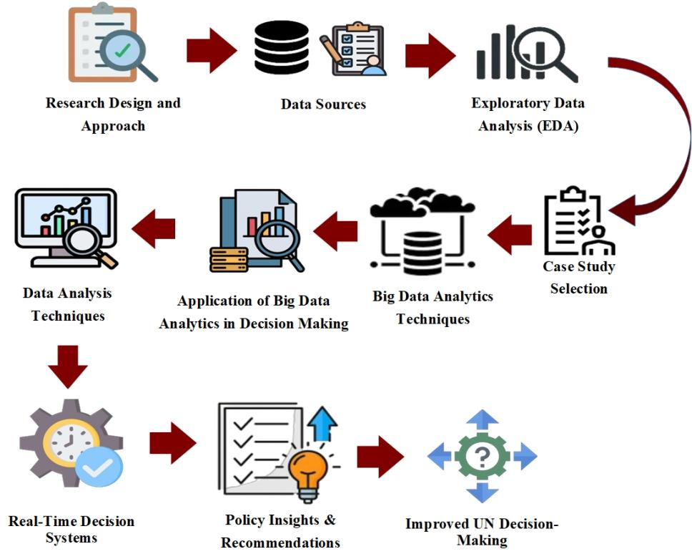

Figure 1: Proposed Methodology for Leveraging BDA in Enhancing UN Decision-Making

3.1 Research Design and Approach
The information referenced is used to evaluate global migration flows, crisis hotspots, and future displacement forecasts to support the evidence base of decision-making within UN APIs and structures. In preparation, a few additional datasets were appended to the Kaggle datasets: there are datasets from UN Global Pulse reports, open-data repositories from WHO, and SDG dashboards with greater levels of resolution for humanitarian planning and policymaking.
The research framework is structured into three phases:
(1)Exploratory Phase: In this stage, we attempt to determine the extent to which the big data phenomenon is being used in the UN and other international organizations. This phase includes consideration of UN policies and procedures, digital transformation plans, reports, and frameworks to determine how big data is being used in organizational decision-making. The analysis in this stage is based on the Global Governance Theory, which emphasizes the role of international organizations and transnational institutions in decision-making on global issues such as refugee flows and climate change. Under this theoretical framework, big data is seen as a tool to optimize global governance by improving decision-making efficiency and enhancing transparency and responsiveness in global governance systems. Additionally, we reviewed innovative trends and methods of data governance in the literature and conducted international case studies. This phase laid the foundation for constructing the questionnaire, identifying behaviors of interest in the datasets, and directing the research towards filling knowledge gaps in later phases of the study.
(2)Descriptive Phase: The descriptive phase will consider general questions to understand what big data and analytics manifestations the UN organs may be putting into operation for operational decision-making and strategic decision-making. In this phase, patterns, practices, and problems regarding the use of analytic tools will be identified through surveys, document analysis, and case studies of UN agencies such as UNDP, WHO, FAO, and UNHCR. The key areas of interest will include crisis management, humanitarian assistance planning, resource management, and policy-making. The analysis in this phase incorporates Dependency Theory, which focuses on the imbalances in global north-south relations and their impact on resource allocation and policymaking in developing countries. From this perspective, big data helps identify and analyze global crisis hotspots, enabling more equitable and effective resource distribution. By delving into these patterns, we can uncover how international organizations, through big data, can enhance decision transparency and efficiency, playing a more active role in the global governance system.
(3)Explanatory Phase: This phase aims to confirm the causal relationship between big data usage and improved decision-making within the UN. Making better decisions from using big data may involve resource allocation, policy topics, planning, and disaster prevention through statistical regression, or addressing qualitative circumstances such as news-type data. The survey and interview results will be compared against existing datasets held by UN departments/sample areas to explore the potential of converting results-based predictive analytics and AI-based systems into higher levels of organizational efficiency and strategic objectives in global operations. This phase integrates Constructivist Theory, which emphasizes that the behavior of states and international organizations is constructed through social interactions and norms. From a constructivist perspective, the use of big data is not just a technical tool but also an important mechanism in driving international organizations toward more cooperative and norm-driven decision-making processes. By using data-driven analysis and decision support, international organizations can better adjust their strategies and respond effectively to evolving global crises.
3.2 Data Sources
The research calls for primary and secondary data to develop a holistic view of BDA applications in decision-making activities in the UN. Primary data take recent facts from subject matter experts who are presently engaged in the decision-making process, whereas secondary data offer past trends along with formal datasets for model-based studies. Together these two show that the research is accurate, recent, and with a strong base for conclusion and policy recommendations.
3.2.1 Primary Data
The principal data for this study were collected through structured questionnaires and semi-structured interviews from stakeholders and professionals in various UN organizations like UNHCR, WHO, and UNDP. These interviewees include data scientists, policy analysts, and decision-makers who are working currently on handling big data and framing policies at the global level. The questionnaires are designed to collect quantitative data on adoption of big data tools, whereas the interviews are carried out to collect qualitative data on challenges, opportunities, and current practices within decision-making. The collection of primary data is undertaken with the view to understanding current organizational strategies in real-time, identifying current limitations, and exploring how BDA is currently being applied in UN operations to help inform planning and humanitarian response.
3.2.2 Secondary Data
This study employed most of the secondary dataset of the UNHCR Refugee Dataset accessed from Kaggle. The dataset contains detailed historic and recent data of refugees, spanning from 1951 to 2024, for over 190 countries. A valuable source of data was thus provided for asylum seekers, internally displaced persons (IDPs), returnees, refugee populations, and stateless persons. The data, therefore, gets scrutinized to understand worldwide migration flows, crisis hotspots, and forecast displacement trends to inform evidence-based decisions by the UN. Other datasets that vary, alongside the Kaggle data, offer more weight to the analysis and context to humanitarian planning and policy-making, such as those from UN Global Pulse reports, WHO open data repositories, and SDG dashboards.
3.3 Exploratory Data Analysis (EDA)
Exploratory data analysis is crucial in analyzing and deriving useful information from the refugee dataset gathered by the UNHCR to support the decision-making processes of the UN, which is data-dependent. The aim is to examine the data both visually and statistically to extract the trends of the past, the spatial and geographical migration, and the relationship between the refugee flows and the severity of the crises as well as the aid provided by the UN. Initially, the trends in refugees over time are analyzed by looking at how the number of refugees changes over time and region. Data are classified by region and by year. The total number of refugees for each time period is then obtained. Let $R_{r}$ be the number of refugees in region $r$ in year $y$ and $N_{p}$be the number of refugees is Eq (1):
$N_{y}=\sum_{r-1}^{m}{ }R_{r,y}$ (1)
Where, $m$ is the number of regions. The equation makes it easier to calculate annual totals that are illustrated through line and bar graphs and assist in detecting abrupt changes in the refugee movement. To this end, spectacular spikes in $N_{y}$, for example, from 2014 to 2016 project the Syrian refugee crisis, whereas sharp rises experienced in 2022 may be attributed to the war in Ukraine. Analysis of these trends offer key insights in terms of wars and international pattern of displacement. The following action of the EDA explores determining the principal countries that export and import refugees. For the UN, the information is essential for efficient allocation of resources as well as for prioritization of urgency-affected areas. The data set is divided based on country of origin and country of asylum. Following this, the total number of refugees coming from a country $c$, $S_{c}$, and the total number of refugees from all countries hosted by a country $c$, $H_{c}$, are defined as Eq (2):
$S_{c}=\sum_{y-1}^{n}{ }R_{cy}^{\text{origin }} \text{ and } H_{c}=\sum_{y^{-1}}^{n}{ }R_{cy}^{\text{asplum }}$ (2)
where $R_{c,y}^{\text{origin }}$represents the outflow of refugees from country $c$ and $R_{c,y}^{axylam}$ represents the refugees hosted by country and year. By ranking $S_{c}$ and $H_{c}$, the analysis brings out the countries which contribute most to the refugees’ movements and the ones which provide the maximum support. These insights are captured using bar charts and heat maps, which indicate that Syria, Afghanistan, and Venezuela are the major sources while Turkey, Germany, and Uganda are the leading host countries.
In the exploratory data analysis, we look into how refugee flows, the severity of crises, and UN humanitarian aid are related. A crisis severity index $C$ is constructed with inputs like conflict intensity, death rates, and displacement triggers, while $A$ represents the UN's humanitarian aid allocation for that year. The magnitude and nature of the correlation between these variables would be measured by the Pearson correlation coefficient, which is given as Eq (3):
$rX,Y=\frac{\sum_{i=1}^{n}{ } \left(X_{i}-\overset{‾}{X}\right)\left(Y_{i}-\overset{‾}{Y}\right)}{\sqrt{\sum_{i=1}^{n}{ } {\left(X_{i}-\overset{‾}{X}\right)}^{2}}⋅\sqrt{\sum_{i-1}^{n}{ } {\left(Y_{i}-\overset{‾}{Y}\right)}^{2}}}$ (3)
were $X,Y$ in $\{R,C,A\}$ with $\overset{‾}{X}$, $\overset{‾}{Y}$ being the mean values of the respective variables and n being the total number of observations. A large value of $r_{B,C}$ indicates that deep crises have a direct effect on increased movements of refugees, whereas a high $r_{R-A}$ value indicates that the UN humanitarian aid is released pari passu with trends in displacement. A low value of $r_{R.A}$ would, on the other hand, mean less resource overlap and hence would determine areas where intervention policies are needed. The EDA, using the above analysis, directs focus on refugee challenges at a global scale and defines high-interest domains that guide UN-level policies. These observations become important for the subsequent stages of predictive and prescriptive analytics to ensure that the UN's approach on big data can solve those challenges from a humanitarian perspective.
3.4 Case Study Selection
Case selection is part of this research design, thus making the findings of the research relevant, significant, and beneficial to humanitarian decision-making in real life. The following are the guidelines that inform case study selection:
Organizational Relevance: As the global leader in refugee flow management, humanitarian aid, and crisis response, the UN is the ideal candidate for a paradigmatic case study. Since the UN operates in a complex international environment, it is best placed to provide learning experiences regarding the application of Big Data Analytics (BDA) in large-scale decision-making. Based on Global Governance Theory, the UN, as a key component of the global governance system, is responsible for coordinating and addressing global crises (such as refugee issues, climate change, etc.). This theory emphasizes the role of international organizations in solving transnational issues through collaboration and information-sharing in a globalized context, where big data analytics serves as a crucial tool to improve decision-making effectiveness and enhance global crisis response. The work of the UN can provide valuable insights into how big data can optimize decision processes and improve global governance.
Scale of Big Data Adoption: At the scale of big data platforms and BDA frameworks, the UN processes vast amounts of data, including data on millions of refugees, satellite imagery, and field reports from all continents. As a typical example of big data usage in global development, the UN is able to forecast and provide data on refugee movements, asylum applications, and historical flow patterns. From the perspective of Dependency Theory, the UN’s decisions not only concern the efficiency of resource distribution but also address the power asymmetries in global north-south relations. Big data helps identify and analyze the challenges faced by developing countries in terms of resource scarcity and policy-making, thus driving more equitable resource allocation and improving global governance.
Availability of Documented Data: The refugee dataset is maintained and verified by the UNHCR and is freely available across platforms like Kaggle and the UNHCR Data Portal. This dataset covers refugee population numbers, migration routes, and aid distribution across countries. Therefore, ensuring the credibility of the data and maintaining complete transparency in the modeling of refugee movements is essential for sound decision analysis within the UN system. The analysis in this phase also draws on Constructivist Theory, which suggests that the behavior of actors and the rules in international relations are constructed through social interactions and norms. From this perspective, big data is not merely a technical tool, but a mechanism to promote more cooperative, norm-driven, and transparent decision-making processes within international organizations. By using big data analysis, the UN can enhance norm-building and coordination within global governance, fostering a more inclusive international decision-making process.
Geographical and Humanitarian Diversity: The UN intervenes in various geographic zones around the world, often affected by conflict, natural disasters, and political injustices. The response to global displacement and regional differences in policy environments, resource availability, or socio-political characteristics always impacts big data-augmented decision-implementation systems. These differences are synthesized from relevant data from various continents and crisis areas to influence the final decision-making process. Combining this with Global Political Economy Theory, the UN must consider the political and economic structures and development disparities across regions when addressing global crises. Big data analytics can help the UN identify disparities in policy implementation and resource allocation across different regions, thereby optimizing the allocation of aid and resources in response to global crises.
Given the mentioned selection criteria, this research is a contemporary case on the real implications of the UN's operations worldwide. The level of guaranteed robustness ensures that the findings are complete enough to be directly applied to improving humanitarian decision-making and policymaking at the international institutional level, particularly in the context of BDA. By incorporating Global Governance Theory, Dependency Theory, and Constructivist Theory, this research provides a deeper political theoretical foundation for understanding how international organizations use big data to drive decision-making, while strengthening the international political perspective of the study.
3.5 Big Data Analytics Techniques
The methods of BDA form a core pillar in the proposed framework that aids the UN in extracting actionable knowledge from large streams of data on refugees. Since global refugee movements imply big and high-dimensional datasets from different sources, the proposed framework federates the three important strands of analyses-descriptive, predictive, and prescriptive analytics. Together they provide an in-depth image of history in trends, forecast, and data-driven evidence-based decision-making recommendations.
Figure 2 illustrates an Integrated BDA Framework for enhancing UN decision-making. Descriptive Analytics (H1) yields Data-Driven Insights, supported by BDA Capabilities (H3, H8). Such knowledge combined with Predictive Analytics (H7) and Prescriptive Analytics (H4) enhances Big Data Decision-Making Quality (H5). Better decision-making leads to better UN policies and utilization of resources (H6), and forecasting models are able to directly affect the outcome as well (H2). At a more basic cognitive level, the task appears to be an issue in knowledge representation.

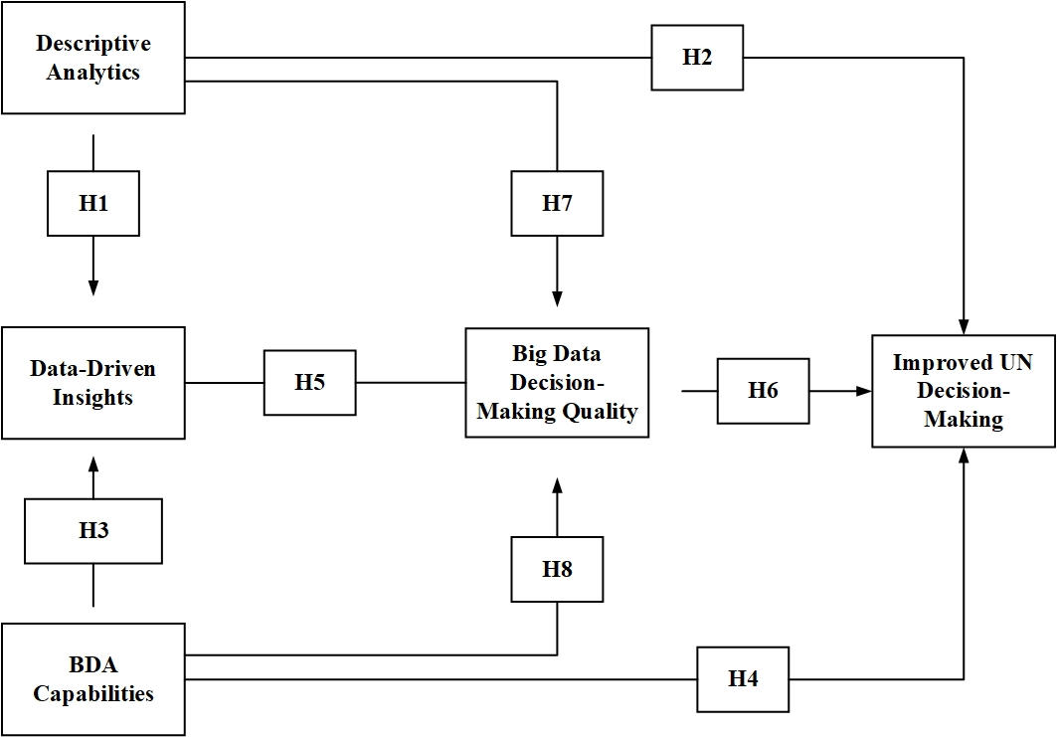
Figure 2: Integrated BDA Framework for Enhancing UN Decision-Making
This paragraph briefly describes how three Big Data Analytics (BDA) methods help the UN address humanitarian crises:
Descriptive Analytics: Summarizes and visualizes past refugee movement trends, helping identify patterns, reception and origin countries.
Predictive Analytics: Based on past trends and models, it forecasts future refugee movements, assisting the UN in preparing budgets, logistics, and response measures, thereby enhancing the strategic and effective decision-making process.
Prescriptive Analytics: Provides evidence-based optimal recommendations for resource allocation and policy decisions, ensuring efficient aid distribution and maximizing impact.
These analytical methods help the UN extract insights from historical data, predict future trends, and devise resource allocation strategies to address global humanitarian crises.
3.6 Applications of Big Data Analytics in Decision-Making
BDA has an instrumental effect on improving decision-making for international organizations such as the UN. By gathering, processing, and analyzing vast streams of data on refugee flows, humanitarian operations, and crisis reporting, the UN is in a position to make faster, smarter, and evidence-based decisions. With the integration of big data technologies, the organization can optimize the use of resources, improve policy formulation, and expand operational efficiency. The following are the key applications relevant for this study:
- Refugee Flow Forecasting: Analysis of big data allows for the prediction of future refugee flows based on utilizing previous displacement trends, factors related to conflict, and environmental data. Based on machine learning models, the UN can anticipate unforeseen migration spikes and place resources in advance in order to respond more quickly.
- Optimized Resource Allocation: Using predictive and prescriptive analytics, the UN can optimize the distribution of food, shelter, medicine, and finances. It keeps a real-time account of refugees and monitors the degree of severity of the crisis. Big data optimizes the allocation of high-priority territories first and decreases the response time in deploying resources.
- Policy Formulation and Strategic Planning: Evidence from big data provides a sound foundation for policy-making based on evidence. Analyzing correlation among refugee flows, conflict patterns, and distribution of global aid, the UN can come up with effective policies for long-term crisis management and sustainable refugee support plans.
- Real-Time Crisis Monitoring: Through the integration of real-time decision-making systems and big data platforms, the UN can monitor newly emerging humanitarian crises in real-time. Live processing platforms such as Apache Kafka and Spark Streaming enable real-time analysis of patterns of displacement, triggering instant alerts to decision-makers when a crisis is escalating. This allows for timely action rather than intervening late.
- Enhanced Decision Support Systems: BDA empowers the UN with interactive dashboards designed on Power BI, Tableau, or Python Dash. The dashboards visualize refugee information, crisis areas, and aid distribution in real time, enabling authorities to make educated decisions quickly and effectively.
3.7 Data Analysis Techniques
Whereas BDA Techniques address data processing at an extensive level, Data Analysis Techniques (analytical approach) look at how conclusions from analyzed data are drawn for evidence-based decision-making at the ONU. There is a step-wise process comprised of thematic analysis, descriptive statistics, inferential statistics, and correlational analysis, giving both qualitative and quantitative outputs associated with flows of refugees and dispersal of assistance.
- Thematic Analysis: Working with qualitative data such as UN policy reports, humanitarian assessments, and interviews with refugees, the thematic analysis aims to seek out recurring patterns and themes existing in the data. These include categorizing issues such as causes of conflict, reasons for migration, and problems arising in the process of delivery of aid to better understand some causes of refugee migrations and attempt to address some pressing issues that must be addressed by policymakers.
- Inferential Statistics: This type allows generalization and prediction about world refugee patterns by decision makers on the base of some sample data. The said methodology allows one to test a hypothesis on whether crises and refugees are related, as well as giving a measure to judge the effectiveness of aid programs. The UN, then, might steer away from describing basically historic facts to set up concrete familiar projections for actual policy-making.
- Correlation Analysis: It shall explore the direction and intensity of relations between various measures, refugee flows, levels of crisis severity, and actual allocations of UN aid monies being amongst others. It decides if increases in numbers of refugees are true reflections of intensification in conflict or escalation in policy responses and so the UN can begin to see whether its resource allocation is linked with naked needs. An evidence-based approach on the other side ensures that the humanitarian intervention is very well targeted and efficient.
In contrast, Data Analysis Techniques zero in on thematic analysis, descriptive statistics, inferential statistics, and correlation analysis to draw meaningful insights, test hypotheses, and establish any relationships between flows of refugees, severity of crisis, and distribution of UN aid. Together, these models comprise the foments of a holistic framework that marries big data processing with advanced analytics so that UN decision-makers can embark on a journey of data-driven decisions in the formulation of humanitarian response and policy.
3.8 Real-Time Decision Systems
This is the process of integrating BDA with real-time decision-support platforms in order to facilitate the UN ability to rapidly respond to emerging humanitarian crises. By utilizing technologies like Apache Kafka, Spark Streaming, and real-time dashboards created using Power BI, Tableau, or Python Dash, refugee data from multiple sources are streamed, analyzed, and visualized on an ongoing basis. This enables UN officials to detect sudden refugee flows, trace crisis development, and respond with resources right away via real-time intelligence. Real-time systems make decisions based on data not just predictive but also proactive and instant, improving efficiency in humanitarian response overall.
3.9 Policy Insights & Recommendations
The findings of the analysis are translated into practical and real-world policy recommendations for the UN and other worldwide organizations. After descriptive, predictive, prescriptive, and correlation analysis, the results are applied for detecting refugee hotspots, predicting potential displacement trends, and ranking countries that require urgent humanitarian aid. The recommendations help the UN create evidence-based resource planning, crisis planning, and refugee management strategies in the long term. By connecting analytical outcomes with policymaking, the process makes sure that data-driven findings influence the formulation of strategies for tackling real-world humanitarian challenges effectively.
3.10 Improved UN Decision-Making
This measure is intended to enhance the ability of the UN to make faster, smarter, and fact-based decisions based on inferences derived from big data. Through the incorporation of forecasting, optimization, and interactive dashboards, UN leadership can monitor refugee flows in real-time and forecast impending humanitarian crises prior to their occurrence. Such inferences enable the agency to deploy resources more effectively, plan preventive interventions, and improve operational performance. By connecting analysis to decision-making, the UN is better able to respond to refugee movements and deliver timely and informed humanitarian intervention.
4.Result and Discussion
This study explores the integration of Big Data Analytics (BDA) into decision-making processes within the United Nations (UN), particularly addressing contemporary challenges such as migration crises. The findings reveal that BDA significantly enhances the UN's ability to forecast refugee flows and identify regions at high risk. By leveraging real-time data as key input, the UN is able to conduct selective evaluations using predictive and prescriptive analytics, which enable the identification of optimal resource allocation strategies in crisis management. Consequently, decisions are made more rapidly and supported by data, allowing humanitarian interventions to be more agile and proactive. This approach shifts the focus from short-term, reactive responses to long-term planning and policy outcomes.
Table 1: Refugee Data Summary Statistics
Statistic |  | Year | Country | Origin | level
N | Valid | 85187 | 85187 | 85187 | 85187
N | Missing | 0 | 0 | 0 | 0
Mean |  | 2007.83 | 94.90 | 106.46 | 7.14
Std. Error of Mean |  | .015 | .189 | .218 | .023
Mode |  | 2014 | 176 | 54 | 5
Std. Deviation |  | 4.458 | 55.144 | 63.722 | 6.685
Variance |  | 19.873 | 3040.843 | 4060.453 | 44.692
Minimum |  | 2000 | 0 | 0 | 0
Sum |  | 171040989 | 8084581 | 9069080 | 607996

Table 1 gives a statistical description of the four variables: Year, Country, Origin, and Level, among all 85,187 valid observations without missing data. The mean values indicate the average year to be 2007.83 while the countries averaged at 94.90, origins at 106.46, and levels at 7.14. The standard deviations are 4.458 for the year, 55.144 for the country, 63.722 for origin, and 6.685 for the level, thus showing data variability. The mode values are 2014, 176, 54, and 5 for year, country, origin, and level, respectively. Minimum values stand at 2000 for year and 0 for either country, origin, or level. The sums are recorded as 171,040,989 for the year and of similar nature for the rest. These statistics give descriptions on the data's central tendency, spread, and distribution.
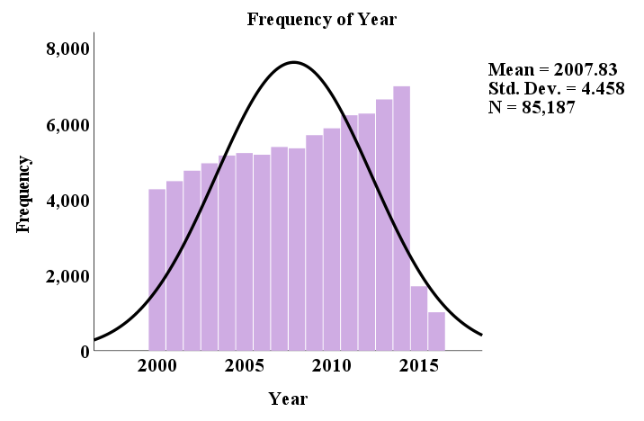
Figure 3: Frequency Distribution of Year
Figure 3 shows the frequency distribution of the Year variable, with data ranging from 2000 to 2015. The x-axis represents the year while the y-axis represents the frequencies of occurrence of observations for each year. Colored in purple, the category-wise bars of the histogram show the frequency of observations per year. The black normal curve shows the overall distribution. The mean of Year is 2007.83 with a Standard Deviation equal to 4.458, meaning that data is centrally located at 2007 with a considerable margin of dispersion. The total number of observations, N, is 85,187, representing the sample size for this analysis.
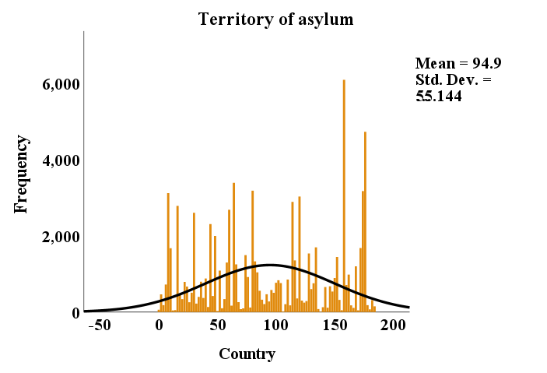
Figure 4: Frequency Distribution of Territory of Asylum
The frequency distribution of asylum territory values (Country values) is depicted in Figure 4. The x-axis ranges from -50 to 200 and holds the country values, and the y-axis stands for the frequency of each country value. The orange bars stand for the frequency, while a black line is overlaid showing the distributional pattern as given by the normal distribution curve. According to the data, the mean is 94.9, with the standard deviation being equal to 55.144, which is a moderate variation. The distribution shows that the data is spread out with a few frequency peaks since some countries registered a notably high frequency of asylum seekers.

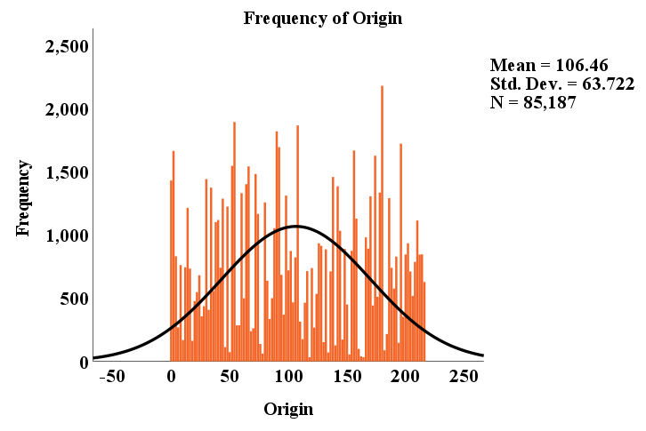
Figure 5: Frequency Distribution of Origin
The distributional representation of Origin is given in Figure 5. The x-axis corresponds to the values of origin and ranges from -50 to 250, whereas the y-axis corresponds to the frequencies of the values. The orange bars indicate the number of instances for each origin value, contrasting with the black line of the smooth curve indicative of an approximate normal curve for the data. This distribution has a mean of 106.46 and a standard deviation of 63.722. It would thus be fair to consider the variable to have moderate variability. The total number of observations is 85,187, this being the sample used to conduct these analyses.
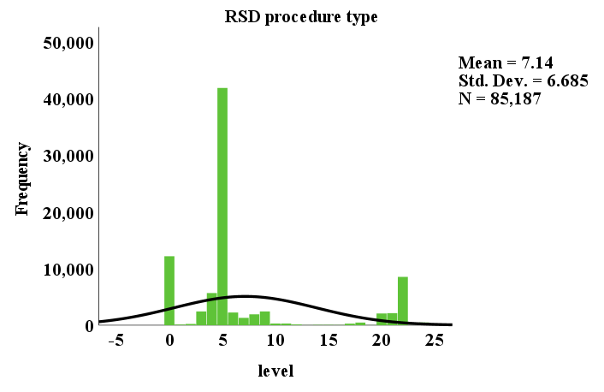
Figure 6: Frequency Distribution of RSD Procedure Type by Level
Figure 6 illustrates the frequency distribution for the type of RSD method by category level. The x-axis indicates levels from -5 to 25, whereas the y-axis shows the frequency of the occurrence of each level. Green bars on the graph indicate the number of instances recorded in each level or class, with the black line referring to the normal distribution curve depicting the entire range of the data. The mean value is 7.14 with a standard deviation of 6.685, representing moderate variability. n = 85,187 is the total sample size, with a sharp peak at level 5 suggesting an accumulation of observations around this value.
Table 2: Descriptive Statistics Summary
Statistic | N | Minimum | Sum | Mean |  | Std. Deviation
Statistic | Statistic | Statistic | Statistic | Statistic | Std. Error | Statistic
Pending Start | 84911 | 0 | 11733063 | 138.18 | 6.633 | 1932.820
UNHCR Start | 85049 | 0 | 2654758 | 31.21 | 1.741 | 507.658
Applied Year | 84907 | 0 | 14365989 | 169.20 | 6.620 | 1929.057
Valid N (listwise) | 84740 | - | - | - | - | -

This table 2 gives descriptive statistics for a dataset having various variables. For "Pending Start," the minimum value is 0, the sum being 11,733,063, and the value for average gives a value of 138.18, which means the average pending start value. The standard deviation is 6.633, indicating the variation being moderate. For "UNHCR Start," the minimum is 0, the sum is 2,654,758, and the mean equals 31.21. The standard deviation is 1.741, which asks for less variation. "Applied Year" stands at the minimum of zero, 14,365,989 in sums, an average of 169.20, and a standard deviation of 6.620.
Table 3: Descriptive Statistics for Decision Categories
Statistic | N | Minimum | Sum | Mean | Std. Error | Std. Deviation
Recognized Dec | 84991 | 0 | 2982595 | 35.09 | 1.952 | 569.107
Other Dec | 85074 | 0 | 1406004 | 16.53 | 3.464 | 1010.465
Rejected | 84911 | 0 | 6257558 | 73.70 | 2.511 | 731.760
Closed Other | 84881 | -1 | 3484566 | 41.05 | 1.593 | 464.123
Total Dec | 84788 | 1.0 | 14131620.0 | 166.670 | 5.6947 | 1658.1919
Valid N (listwise) | 84515 | - | - | - | - | -

Descriptive statistics for the five variables are provided in Table 3. The variable "Recognized Dec" has 84,991 observations, with a minimum value of 0, a total sum of 2,982,595, a mean of 35.09, and a standard deviation of 569.107. "Other Dec" has 85,074 observations, with a minimum value of 0, a total sum of 1,406,004, a mean of 16.53, and a standard deviation of 1,010.465. "Rejected" has 84,911 observations, with a minimum value of 0, a total sum of 6,257,558, a mean of 73.70, and a standard deviation of 731.760. "Closed Other" has 84,881 observations, with a minimum of -1, a total sum of 3,484,566, a mean of 41.05, and a standard deviation of 464.123. "Total Dec" has 84,788 observations, a sum of 14,131,620, mean of 166.67, and a standard deviation of 1,658.19, while Valid N (listwise) is 84,515.
Table 4: Variance of Decision Categories
Statistic | Variance
Recognized Dec | 323883.043
Other Dec | 1021039.875
Rejected | 535472.799
Closed Other | 215410.438
Total Dec | 2749600.435
Valid N (listwise) | -

Table 4 presents the variance for the different categories: Recognized Dec, Other Dec, Rejected, Closed Other, and Total Dec. The variance for the Recognized Dec is 323,883.043, whereas Other Decins has a much higher variance of 1,021,039.875. The category of Rejected has a variance of 535,472.799, whereas a 215,410.438 variance is observed for Closed Other. On the other hand, Total Dec shows 2,749,600.435 as the variance, which is the overall variance of all categories. The table sets forth that the Valid N (listwise) is not provided, which could mean that this specific statistic is absent from the data set.
Table 5: Predictive Analytics Model Summary
Model | R | R Square | Adjusted R Square | Std. Error of the Estimate
1 | .887ª | .787 | .787 | 892.105

The model summary displays the results from a predictive analytics model in Table 5. The predictors and the outcome variable are highly correlated with an R-value of 0.887. The R-Square value of 0.787 means that approximately 78.7 percent of the variation in the dependent variable is accounted for by the model. The Adjusted R-Square value of 0.787 adjusts the R-Square for the number of predictor items which provides an accurate result. The Standard Error of Estimate is 892.105, which represents the average error in prediction for this model.
Table 6: ANOVA
Model |  | Sum of Squares | df | Mean Square | F | Sig.
1 | Regression | 248545740922.641 | 8 | 31068217615.330 | 39037.716 | .000^{b}
1 | Residual | 67209644233.045 | 84450 | 795851.323 | - | -
1 | Total | 315755385155.686 | 84458 | - | - | -

The analysis of variance (ANOVA) table in Table 6 corroborated that the regression model was statistically significant. The regression Sum of Squares was 248,545,740,922.641 with 8 degrees of freedom, the Mean square of the regression was 31,068,217,615.330. The calculated F-value is exceptionally high, at 39,037.716, with a p-value of .000, confirming the model is highly significant. The residual Sum of Squares was 67,209,644,233.045, with 84,450 degrees of freedom. The total Sum of Squares was 315,755,385,155.686; therefore, the indicate significantly supported the predictive strength of the model.
Table 7: Regression Coefficients for Predictive Model
Model |  | Unstandardized Coefficients |  | Standardized Coefficients | t | Sig.
 |  | B | Std. Error | Beta | t | Sig.
1 | (Constant) | 12.687 | 3.098 | - | 4.095 | .000
1 | Pending Start | -.194 | .004 | -.194 | -47.942 | .000
1 | UNHCR Start | -.529 | .011 | -.137 | -46.709 | .000
1 | Recognized Dec | 1.246 | .006 | .368 | 200.074 | .000
1 | Other Dec | 1.034 | .003 | .542 | 338.281 | .000
1 | Rejected | .970 | .005 | .368 | 204.374 | .000
1 | Closed Other | .480 | .008 | .115 | 61.344 | .000
1 | Pending End | .165 | .004 | .164 | 41.118 | .000
1 | UNHCR End | .648 | .010 | .191 | 64.211 | .000

Table 7 presents the model coefficients, which reflect the impact of various factors on refugee decision outcomes. The negative coefficient for Pending Start (-0.194, beta = -0.194) indicates that delays in processing negatively affect decision outcomes, underscoring the importance of timely intervention (t = -47.942, p = 0.000). Similarly, UNHCR Start shows a negative effect with a coefficient of -0.529 (beta = -0.137), suggesting that delays in UNHCR involvement hinder effective decision-making (t = -46.709, p = 0.000). On the positive side, Recognized Dec (coefficient = 1.246, beta = 0.368) demonstrates that faster recognition of refugees leads to better decision outcomes, highlighting the role of BDA in improving efficiency (t = 200.074, p = 0.000). Other Dec (coefficient = 1.034, beta = 0.542) shows a strong positive impact on decision outcomes, while Rejected (coefficient = 0.970, beta = 0.368) also plays a key role in shaping resource allocation decisions (t = 204.374, p = 0.000). Finally, Closed Other (coefficient = 0.480, beta = 0.115) indicates that even closed cases moderately affect decision-making (t = 61.344, p = 0.000). All predictors are statistically significant (p = 0.000), reinforcing the value of BDA in improving the speed, accuracy, and efficiency of decision-making in humanitarian operations.
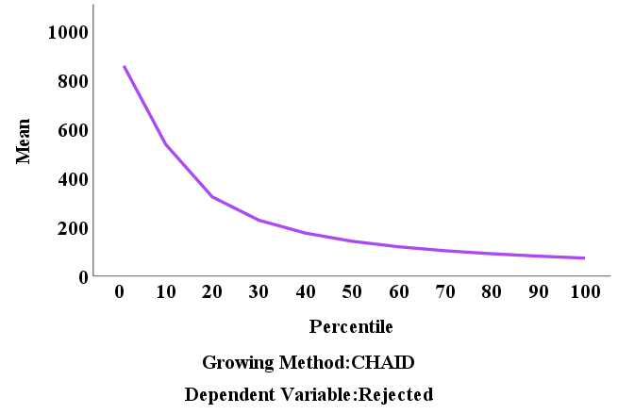
Figure 7: Percentile vs. Mean for Rejected Variable
Figure 7 shows the percentile versus the mean for the Rejected variable, using the CHAID growing method. The x-axis is for percentiles and runs from 0 to 100, while the y-axis shows the means, which decrease as the percentile increases. The graph starts at the lower percentiles of about 1,000 and goes down gradually to around 200 at the higher percentiles. This clearly displays the chance of being rejected and gives the distribution of rejection rates over various percentiles.
Table 8: Pearson Correlation Matrix
Variable |  | Pending Start | UNHCR Start | Applied Year
Pending Start | Pearson Correlation | 1 | .269** | .138**
Pending Start | Sig. (2-tailed) | - | .000 | .000
Pending Start | N | 84911 | 84902 | 84747
UNHCR Start | Pearson Correlation | .269** | 1 | .155**
UNHCR Start | Sig. (2-tailed) | .000 | - | .000
UNHCR Start | N | 84902 | 85049 | 84816
Applied Year | Pearson Correlation | .138** | .155** | 1
Applied Year | Sig. (2-tailed) | .000 | .000 | -
Applied Year | N | 84747 | 84816 | 84907

In Table 8, the Pearson Correlation coefficients are presented for three variables: Pending Start, UNHCR Start, and Applied Year. Pending Start versus UNHCR Start have a correlation of 0.269 and, thus, share a moderate positive relation that is statistically significant at p=0.000. The correlation between Pending Start and Applied Year is 0.138, suggesting a weak positive correlation that is also significant at p=0.000. In the same way, the correlation between UNHCR Start and Applied Year is 0.155, which indicates a weak positive correlation at the p=0.000 level. All correlations are significant at the 0.01 level.
Table 9: Pearson Correlation Matrix for Decision Categories
Variable |  | Recognized Dec | Other Dec | Rejected | Closed Other
Recognized Dec | Pearson Correlation | 1 | .016** | .427** | .102**
Recognized Dec | Sig. (2-tailed) | - | .000 | .000 | .000
Recognized Dec | N | 84991 | 84910 | 84760 | 84733
Other Dec | Pearson Correlation | .016** | 1 | .022** | .122**
Other Dec | Sig. (2-tailed) | .000 | - | .000 | .000
Other Dec | N | 84910 | 85074 | 84825 | 84794
Rejected | Pearson Correlation | .427** | .022** | 1 | .106**
Rejected | Sig. (2-tailed) | .000 | .000 |  | .000
Rejected | N | 84760 | 84825 | 84911 | 84682
Closed Other | Pearson Correlation | .102** | .122** | .106** | 1
Closed Other | Sig. (2-tailed) | .000 | .000 | .000 | -
Closed Other | N | 84733 | 84794 | 84682 | 84881
Total Dec | Pearson Correlation | .570** | .660** | .632** | .436**
Total Dec | Sig. (2-tailed) | .000 | .000 | .000 | .000
Total Dec | N | 84662 | 84701 | 84695 | 84686

Table 9 shows the Pearson correlations among four variables: Recognized Dec, Other Dec, Rejected, and Closed Other, along with the p-values. The correlation between Recognized Dec and Rejected stands at 0.427, moderately positively correlated with significance at p = 0.000. The Other Dec-Closed Other correlation was 0.122 at the same level of significance. Correlation of the total number of decisions with other variables indicated very strong relations: Other Dec (0.660), Rejected (0.632), and Recognized Dec (0.570) at 0.000 level. All correlations are statistically significant.
Table 10: Pearson Correlation between Pending End and UNHCR End
Variable |  | Pending End | UNHCR End
Pending End | Pearson Correlation | 1 | .321**
Pending End | Sig. (2-tailed) | - | .000
Pending End | N | 84982 | 84973
UNHCR End | Pearson Correlation | .321** | 1
UNHCR End | Sig. (2-tailed) | .000 | -
UNHCR End | N | 84973 | 85087

The Pearson correlation between Pending End and UNHCR End is given in table 10, the correlation coefficient being 0.321, suggesting a moderate positive relationship between two variables with a standard p-value of 0.000, thus making the relationship significant. Pending End has an N value of 84,982, while UNHCR End has an N value of 84,973. Also, the correlation between UNHCR End and Pending End is 0.321, again confirming the positive relation between the two.
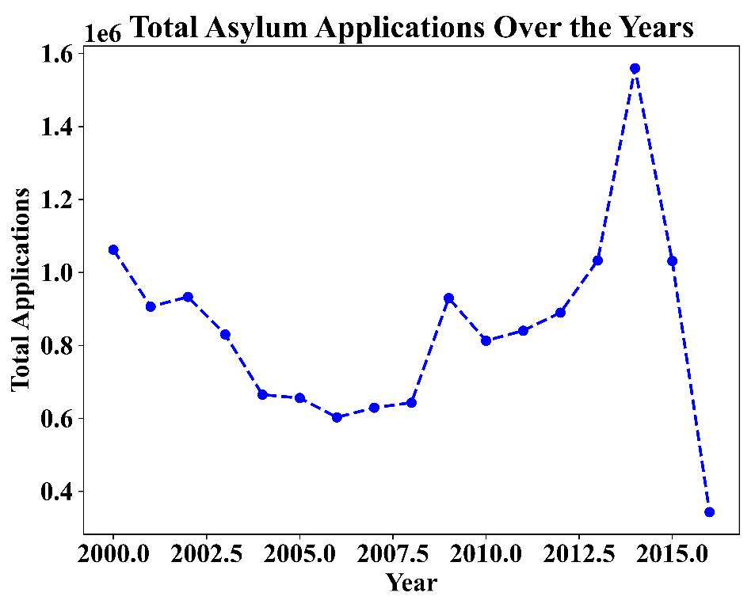
Figure 8: Total Asylum Applications Over the Years
Figure 8 illustrates trends in total asylum applications from the years 2000 to 2015. The y-axis records the total number of applications (in millions), whereas the x-axis records the years. Initially, there was a declining trend, having gone from about 1 million applications in the year 2000, down to about 0.6 million in 2011. Then came a sudden rise in 2012, almost touching 1.5 million applications. A sharp decline ensues once again right before 2015. The dashed blue line shows the fluctuations in asylum applications over the years, highlighting the steep surge that came in 2012.
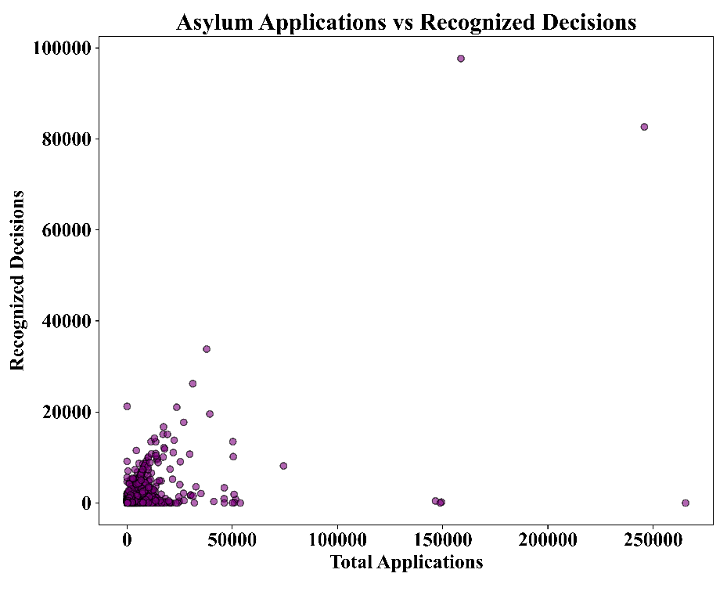
Figure 9: Asylum Applications vs Recognized Decisions
The Asylum Applications vs Recognized Decisions visual shows the overall total of asylum applications (x-axis) and recognized decisions (y-axis) is shown in figure 9. The data indicates a weak correlation with most of them huddling at the lower end of both axes and indicating that for most of the asylum applications, there are lesser recognized decisions. From this also, beyond 50,000 applications, a few points represent higher recognized decisions with some extreme values coming to 100,000 decisions. The distribution, therefore, points toward more decisions rendered compared to that of the applications.
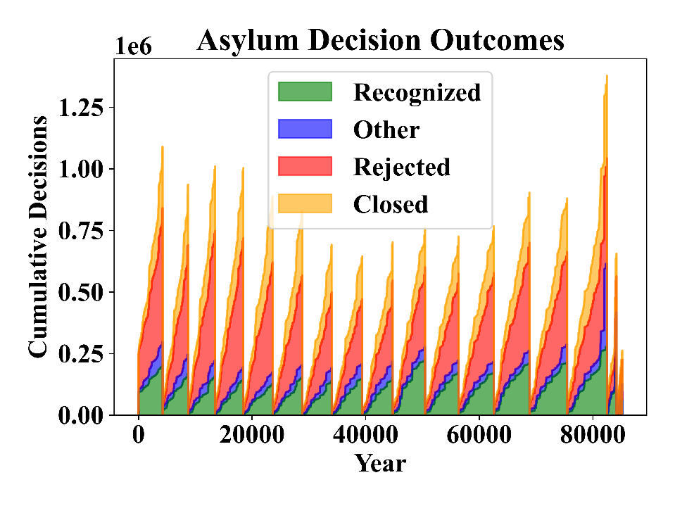
Figure 10: Cumulative Asylum Decision Outcomes Over the Years
The figure 10 shows Asylum Decision Outcomes displays the cumulative asylum decisions over the years. The x-axis represents the years, while the y-axis shows the cumulative number of decisions in millions. The graph uses a stacked area chart to represent four types of decisions: Recognized (green), Other (blue), Rejected (red), and Closed (orange). From the graph, it is evident that Recognized decisions dominate the decision outcomes, with a steady increase over time. The graph shows significant growth in asylum decisions, especially noticeable after certain years, such as 2015, where the number of Closed decisions sharply rises. The cumulative decisions reach up to 1.25 million by the end of the period.
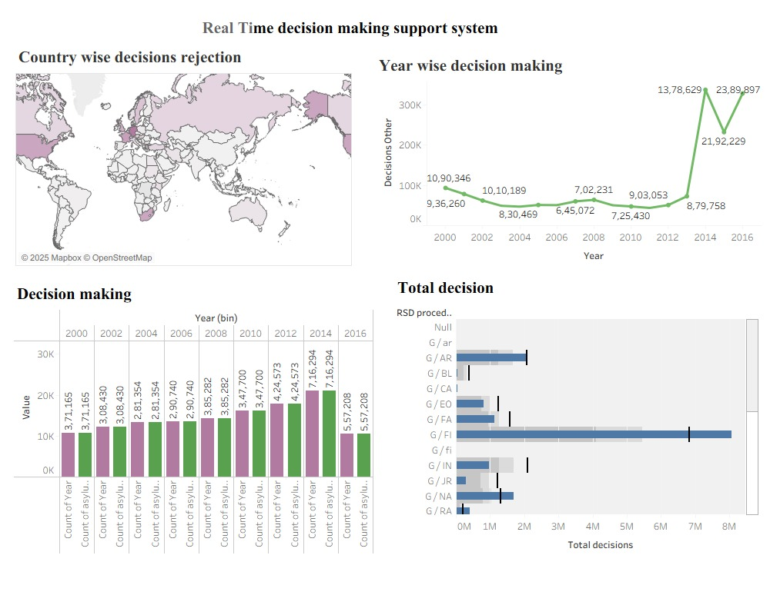
Figure 11: Real-Time Decision-Making Support System Dashboard
The real-time decision-making support system displayed in the image provides a comprehensive view of asylum decisions from multiple perspectives shows in figure 11. This rejection map by country basically gives the refusal incidence in asylum applications worldwide; the various regions are colored with their respective rejection rates. While this visualization describes the annual fluctuation in asylum decisions such as those induced by the unusual spikes between 2012 and 2016 in times of crises and migration waves, the "Decision Making" bar chart compares the years, which is, therefore, a good view on the data concerning how asylum applications and decisions in fact changed over the years. The "Total Decision" histogram can provide an insight into the breakup or comparisons of different categories of asylum decisions across various RSD procedures, with a lot of focus on G/AR and G/FA. Visualizations thus lay forth trends of asylum and aid decision-makers in directing relief in the wake of any real-time crisis for better policy formulation and allocation of resources.
5.Conclusion and Future Scope
Based on the empirical findings, several practical implications and recommendations can be drawn for international humanitarian organizations.
First, international organizations should prioritize the development of integrated data infrastructures that enable real-time data collection, processing, and analysis. Investments in interoperable data platforms can enhance information quality and support timely decision-making during humanitarian crises.
Second, organizations are encouraged to adopt predictive analytics as a core component of crisis preparedness and planning. Reliable forecasting of refugee movements and crisis intensity can improve anticipatory decision-making and reduce reactive responses under time pressure.
Third, prescriptive analytics should be further embedded into operational decision-support systems to translate analytical insights into concrete resource-allocation strategies. By incorporating operational constraints and priority rules, prescriptive models can support more efficient and transparent allocation of humanitarian resources.
Finally, capacity building in data analytics and decision-support systems is essential. Training decision-makers to interpret analytical outputs and integrate them into organizational routines can enhance the practical impact of BDA-driven tools in complex humanitarian settings.
Together, these recommendations highlight how international organizations can leverage Big Data Analytics to strengthen evidence-based decision-making, improve crisis responsiveness, and enhance the effectiveness of humanitarian interventions.
- Data Availability:
Primary Data: https://forms.gle/XHAzqBsRDdvDRYz99
Secondary Data: https://www.kaggle.com/datasets/unitednations/refugee-data
References
【1】 Abbasi, A., Sarker, S., & Chiang, R. H. L. (2020). Big data research in information systems: Toward an inclusive research agenda. Journal of the Association for Information Systems, 21(2), 210–241. https://doi.org/10.17705/1jais.00582
【2】 Alquraish, M. (2025). Digital transformation, supply chain resilience, and sustainability: A comprehensive review with implications for Saudi Arabian manufacturing. Sustainability, 17(10), 4495.
【3】 Argyroudis, S. A., et al. (2022). Digital technologies can enhance climate resilience of critical infrastructure. Climate Risk Management, 35, 100387. https://doi.org/10.1016/j.crm.2021.100387
【4】 Barakat, S., Cochrane, L., & Vasekha, I. (2023). The humanitarian-development-peace nexus for global food security: Responding to the climate crisis, conflict, and supply chain disruptions. International Journal of Disaster Risk Reduction, 98, 104106.
【5】 Brynjolfsson, E., Rock, D., & Syverson, C. (2021). The productivity J-curve: How intangibles complement general-purpose technologies. American Economic Journal: Macroeconomics, 13(1), 333–372. https://doi.org/10.1257/mac.20180345
【6】 Chalvantzis, N., et al. (2024). IW-NET BDA: A big data infrastructure for predictive and geotemporal analytics of inland waterways. IEEE Access, 12, 52503–52523.
【7】 Duan, Y., Edwards, J. S., & Dwivedi, Y. K. (2019). Artificial intelligence for decision making in the era of Big Data—Evolution, challenges, and research agenda. International Journal of Information Management, 48, 63–71. https://doi.org/10.1016/j.ijinfomgt.2019.01.021
【8】 Elgendy, N., Elragal, A., & Päivärinta, T. (2022). DECAS: A modern data-driven decision theory for big data and analytics. Journal of Decision Systems, 31(4), 337–373. https://doi.org/10.1080/12460125.2021.1894674
【9】 Faliagka, E., et al. (2024). Trends in digital twin framework architectures for smart cities: A case study in smart mobility. Sensors, 24(5), 1665. https://doi.org/10.3390/s24051665
【10】 Familoye, I. T., & Toyin, N. S. U. (2024). Navigating the complexities of global security: The role of the United Nations in conflict resolution, safeguarding, and humanitarian aid. World Journal of Advanced Research and Reviews, 23(2), 2433–2449.
【11】 Francisco, M., & Linnér, B.-O. (2023). AI and the governance of sustainable development. An idea analysis of the European Union, the United Nations, and the World Economic Forum. Environmental Science & Policy, 150, 103590. https://doi.org/10.1016/j.envsci.2023.103590
【12】 Grover, V., Chiang, R. H. L., Liang, T.-P., & Zhang, D. (2018). Creating strategic business value from big data analytics: A research framework. Journal of Management Information Systems, 35(2), 388–423. https://doi.org/10.1080/07421222.2018.1451951
【13】 Guo, H., et al. (2022). Measuring and evaluating SDG indicators with Big Earth Data. Science Bulletin, 67(17), 1792–1801. https://doi.org/10.1016/j.scib.2022.07.015
【14】 Hassani, H., Huang, X., MacFeely, S., & Entezarian, M. R. (2021). Big data and the United Nations Sustainable Development Goals (UN SDGs) at a glance. Big Data and Cognitive Computing, 5(3), 28.
【15】 Hassani, H., & MacFeely, S. (2023). Driving excellence in official statistics: Unleashing the potential of comprehensive digital data governance. Big Data and Cognitive Computing, 7(3), 134. https://doi.org/10.3390/bdcc7030134
【16】 Imjai, N., Swatdikun, T., Rungruang, P., Basiruddin, R., & Aujirapongpan, S. (2024). Empowering generation Z accountants in the era of data complexity and open innovation: Nurturing big data analytics, diagnostic, and forensic accounting skills. Journal of Open Innovation: Technology, Market, and Complexity, 10(2), 100308. https://doi.org/10.1016/j.joitmc.2024.100308
【17】 Ikegwu, A. C., Nweke, H. F., Anikwe, C. V., Alo, U. R., & Okonkwo, O. R. (2022). Big data analytics for data-driven industry: A review of data sources, tools, challenges, solutions, and research directions. Cluster Computing, 25(5), 3343–3387. https://doi.org/10.1007/s10586-022-03568-5
【18】 Klievink, B., Bharosa, N., & Tan, Y.-H. (2017). The collaborative realization of public values and business goals: Governance and information management in public–private information infrastructures. Government Information Quarterly, 34(1), 67–79. https://doi.org/10.1016/j.giq.2016.12.002
【19】 Mikalef, P., Boura, M., Lekakos, G., & Krogstie, J. (2019). Big data analytics and firm performance: Findings from a mixed-method approach. Journal of Business Research, 98, 261–276. https://doi.org/10.1016/j.jbusres.2019.01.044
【20】 Niu, Y., Ying, L., Yang, J., Bao, M., & Sivaparthipan, C. B. (2021). Organizational business intelligence and decision making using big data analytics. Information Processing & Management, 58(6), 102725.
【21】 Pashentsev, E. N., & Kolotaev, Y. Y. (2025). Information and communication technologies in political crisis management: Resilience, forecasting, and response. Discov Glob Soc, 3(1), 84. https://doi.org/10.1007/s44282-025-00216-2
【22】 Podgórska, K., Jekaterynczuk, A., Yarosh, O., Kuzmuk, O., & Liubchuk, V. (2024). Support for Ukrainian refugees after Russia invades Ukraine: Aid structure and resilience factors. Case studies of Lublin and Lutsk. European Societies, 26(2), 386–410.
【23】 Ragazou, K., Passas, I., Garefalakis, A., Galariotis, E., & Zopounidis, C. (2023). Big data analytics applications in information management driving operational efficiencies and decision-making: Mapping the field of knowledge with bibliometric analysis using R. Big Data and Cognitive Computing, 7(1), 13. https://doi.org/10.3390/bdcc7010013
【24】 Sharma, A. K., Sharma, D. M., Purohit, N., Rout, S. K., & Sharma, S. A. (2022). Analytics techniques: Descriptive analytics, predictive analytics, and prescriptive analytics. In Decision Intelligence Analytics and the Implementation of Strategic Business Management (pp. 1–14). Springer. https://doi.org/10.1007/978-3-030-82763-2_1
【25】 Wamba, S. F., Akter, S., Edwards, A., Chopin, G., & Gnanzou, D. (2015). How ‘big data’ can make big impact: Findings from a systematic review and a longitudinal case study. International Journal of Production Economics, 165, 234–246. https://doi.org/10.1016/j.ijpe.2014.12.031
【26】 Saadati, T., & Barutcu, B. (2025). Forecasting solar energy: Leveraging artificial intelligence and machine learning for sustainable energy solutions. Journal of Economic Surveys, joes.12678. https://doi.org/10.1111/joes.12678
【27】 Schilling, L., Kaden, J., Bán, I., Berger-Höger, B., & TARGET group. (2025). Development of a generic decision guide for patients in oncology: A qualitative interview study. BMC Med Inform Decis Mak, 25(1), 125. https://doi.org/10.1186/s12911-025-02960-6
【28】 Fowowe, O. O., & Adedapo, A. (2025). Leveraging predictive analytics to optimize business performance and drive operational excellence. International Journal of Computer Applications Technology and Research, 14(02), 66–81.
【29】 Niu, Y., Ying, L., Yang, J., Bao, M., & Sivaparthipan, C. B. (2021). Organizational business intelligence and decision making using big data analytics. Information Processing & Management, 58(6), 102725.
【30】 Hassani, H., & MacFeely, S. (2023). Driving excellence in official statistics: Unleashing the potential of comprehensive digital data governance. Big Data and Cognitive Computing, 7(3), 134. https://doi.org/10.3390/bdcc7030134
【31】 Francisco, M., & Linnér, B.-O. (2023). AI and the governance of sustainable development. An idea analysis of the European Union, the United Nations, and the World Economic Forum. Environmental Science & Policy, 150, 103590. https://doi.org/10.1016/j.envsci.2023.10359
【32】 Nanehkaran, Y. A., et al. (2023). Riverside landslide susceptibility overview: Leveraging artificial neural networks and machine learning in accordance with the United Nations (UN) Sustainable Development Goals. Water, 15(15), 2707. https://doi.org/10.3390/w15152707
【33】 Liu, J., Yu, Y., Chen, P., Chen, B. Y., Chen, L., & Chen, R. (2023). Facilitating urban tourism governance with crowdsourced big data: A framework based on Shenzhen and Jiangmen, China. International Journal of Applied Earth Observation and Geoinformation, 124, 103509. https://doi.org/10.1016/j.jag.2023.103509
【34】 Guo, H., et al. (2022). Measuring and evaluating SDG indicators with Big Earth Data. Science Bulletin, 67(17), 1792–1801. https://doi.org/10.1016/j.scib.2022.07.015

