Research on Algorithmic Ethical Risks and Collaborative Governance Mechanisms of General Artificial Intelligence Embedded in Government Services
Wenwen liu
Human Resources and Social Security Bureau, Suihua City, Heilongjiang Province, Suihua 152000, China
Email：133133033@qq.com
Abstract: With the full-scale penetration of general artificial intelligence (AGI) in the government affairs sector, government services are undergoing a transformation from traditional digitalization to deep intelligence. However, their inherent technical characteristics also bring severe ethical challenges. In response to the ethical risks such as algorithm black boxes, bias solidification, and responsibility drift that arise when AGI is integrated into government services, this study proposes to construct value-aligned and embedded technical endogenous rules, a collaborative system involving multiple stakeholders, and an agile institutional feedback mechanism. This will provide practical references for enhancing the governance efficiency of digital governments.
Keywords: Artificial Intelligence; Government Services; Algorithmic Ethical Risks; Collaborative Governance Mechanism

Introduction
General artificial intelligence, as the driving force leading the new round of technological revolution, is rapidly penetrating public administration, prompting a profound change in the service model of government affairs. Currently, the construction of digital government in China has entered a stage of in-depth advancement. Government functional departments are increasingly emphasizing the use of a large number of pre-trained models, multimodal perception, and other advanced technologies to improve administrative processes. This technology embedding has changed the scale and interaction speed of government information processing, and has demonstrated strong substitutability and enhancing effects in complex scenarios such as intelligent consultation, decision support, and government analysis^{[1]}. However, when general artificial intelligence enhances government efficiency, it also breaks through the administrative power operation mode under the traditional bureaucratic system. Due to the strong emergence and unpredictability of general algorithms, when embedded in the process of public power execution, there is often a strong conflict between algorithm ethics and public values. The inherent opacity of technology and the public transparency attribute required by public services have a natural contradiction. The randomness of algorithm-generated results can affect the stability and seriousness of administrative actions ^{[2]}. Facing this complex picture, relying solely on technical means or administrative orders is no longer sufficient to deal with the complex algorithmic crisis. It is necessary to conduct an in-depth analysis of the potential risk mechanisms of general artificial intelligence in government scenarios. Through scientific identification of risk boundaries and the establishment of collaborative governance paths, it is possible to ensure that artificial intelligence technology develops positively on the public service track and achieve a deep coupling of technological dividends and public value.

1. The application scenarios of general artificial intelligence embedded in government services

1.1 Intelligent interaction and service guidance
Intelligent interaction and service guidance, as the most direct manifestation of general artificial intelligence in the field of government affairs, mainly relies on large-scale language models and natural language processing technologies to reshape the communication methods between the government and the public. Traditional government consultation relies on keyword matching or human customer service, which makes it difficult to provide accurate responses to complex, ambiguous, and long-text semantic requests. However, general artificial intelligence has a strong semantic understanding ability and can accurately grasp the user's true intention through multiple conversations. According to the fragmented needs of users, it can automatically connect relevant data such as policy libraries, legal regulations, and processing procedures behind the scenes, providing users with structured service lists and operation guidelines（Figure 1）. This interaction method transforms government service from a "search-based" model to a "generative" model, eliminating the problem of difficulty in handling affairs caused by the asymmetry of government information. At the same time, by obtaining real-time data from different departments and integrating it logically, general artificial intelligence can provide personalized responses for different individuals' special situations, reducing the need for public travel between different windows. The interaction system has a strong self-learning ability, which can continuously optimize the coverage and accuracy of the knowledge base based on historical consultation records, ensuring the standardization and continuity of government consultation services, and improving the response speed and user experience of government services while reducing administrative service costs.
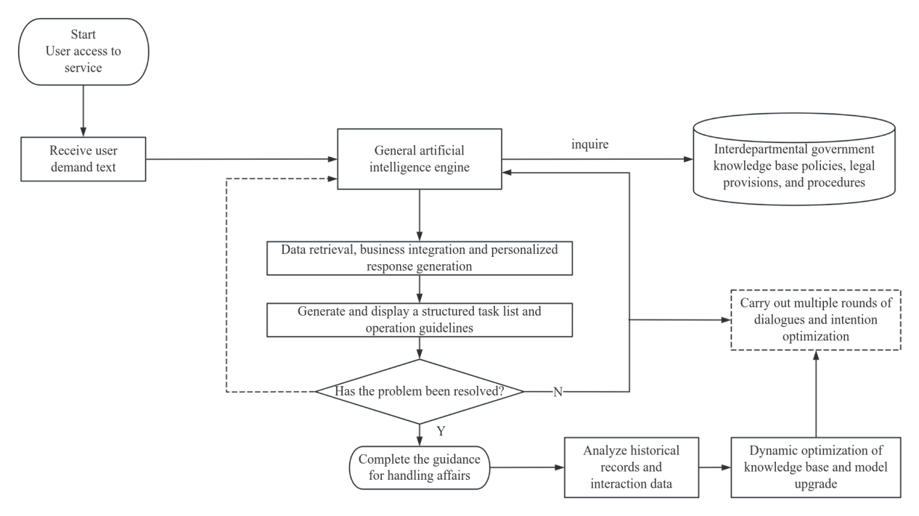
Figure 1: Flowchart of Intelligent Interaction and Service Guidance Based on General Artificial Intelligence

1.2 Document Assistance and Decision Support
In the internal administrative operations of the government, general artificial intelligence integrates deeply into the processes of document handling and decision support, achieving a structural improvement in administrative efficiency. As shown in Figure 2, document processing serves as a crucial support for government operations. General artificial intelligence, relying on its powerful text generation and extraction capabilities, can assist administrative personnel in drafting initial drafts, checking formats, verifying logic, and extracting literature, thereby significantly reducing the time spent on administrative tasks. The deeper application lies in decision support. General artificial intelligence can provide systematic knowledge support to decision-makers by conducting multi-dimensional and cross-temporal correlation analysis of a large amount of historical policy documents, laws and regulations, and government operation data. When faced with complex public affairs, algorithms can automatically identify the connections and contradictions between policies, construct a complete policy context through knowledge graph building, enabling decision-makers to have a comprehensive understanding of the current issues and helping them comprehensively examine the legal basis and historical background of the current problems. Moreover, general artificial intelligence can also conduct compliance reviews and logical arguments on decision drafts, identifying existing institutional loopholes and procedural deficiencies. This assistance model eliminates cognitive biases caused by fragmented information through technical means, ensuring that administrative decisions proceed along a scientific and standardized direction, and enhancing the professionalism and logic of handling complex public affairs in public administration.
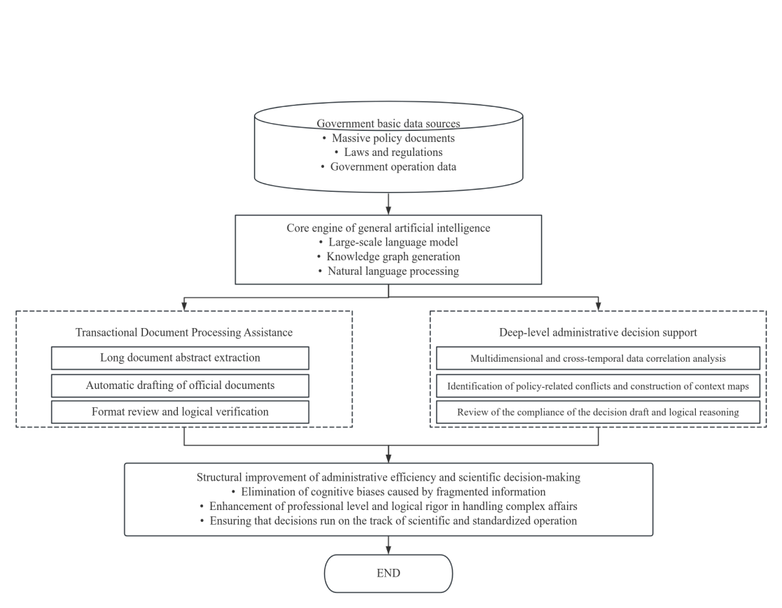
Figure 2: Flowchart of Document Assistance and Decision Support Based on General Artificial Intelligence

1.3 Trend Analysis and Scenario Simulation
Trend analysis and scenario simulation represent an advanced application of general artificial intelligence in government governance, shifting from "post-event handling" to "pre-event prevention". Through predictive modeling and multimodal data processing capabilities of general artificial intelligence, the government can conduct comprehensive monitoring and dynamic analysis of the city's operation, the development of the social economy, and the occurrence and development of emergencies. From the perspective of trend analysis, algorithms can detect the subtle signals hidden in social operation data, identify latent social group demands or social risks, and provide a scientific basis for the government to take proactive measures in advance. General artificial intelligence can build a digital twin foundation, conduct full-process virtual simulation of upcoming policies or planning schemes, and simulate the possible social chain reactions and changes in benefit distribution after policy implementation. By comparing the simulation results under different parameter combinations, predicting the potential benefits and secondary risks of the schemes, and thereby achieving the selection of the optimal policy. This simulation and simulation mechanism eliminates the high trial-and-error cost phenomenon caused by the "pilot first, then promotion" approach in public management, enabling public management to intervene in risk points in advance and achieve precise policy implementation. By strengthening the predictability and coordination of government services through technological means, general artificial intelligence enhances the resilience of the government in responding to public crises, providing a powerful technical lever for the refinement and precision of social governance.

2. Algorithmic ethics risks of embedding general artificial intelligence in government services

2.1 Risk of procedural justice due to the algorithmic black box
The underlying architecture of general artificial intelligence is based on deep learning and extremely large-scale parameters. The process of derivation and generation is highly technologically opaque, forming an algorithmic black box that cannot be penetrated. When the lack of interpretability is directly embedded into the processes of government services and administrative decision-making, the principle of procedural justice in modern administrative law will be compromised. Procedural justice requires that the exercise of public power should have a high degree of transparency. Administrative entities have the obligation to explain the reasons to the parties concerned and ensure that citizens understand the factual basis and the reasons for the administrative decision. However, for complex government affairs demands, the output results of general artificial intelligence are the outcome of a large number of nonlinear operations at nodes. Neither system developers nor administrative executors can accurately trace back to the generation trajectory of a specific decision^{[3]}. Due to the unknowability of the decision logic, government terminals cannot provide a clear and legal basis when rejecting applications or imposing administrative penalties. When the public faces unfavorable administrative treatments, their inherent rights to know, present their cases, and defend themselves are substantially blocked because they cannot penetrate the technical barriers to obtain the key information for algorithmic determination. Moreover, the technical flaws of general artificial intelligence at the time of information generation can cause logical output of false information. Due to the hidden error evolution links in the black box mechanism, administrative decisions have fallen into an irrational self-running state. The algorithmic black box makes the transparency review of administrative actions lose its substantive meaning, making the legal procedures in the digital age merely formalistic, and weakening the legal credibility of the government based on procedural justice.

2.2 Social Distribution Risks Caused by the Solidification of Prejudices
The cognitive model and output quality of general artificial intelligence largely depend on the large amount of training data and historical operation records used in the early stage. Due to the existence of structural inequalities in real society, such as those based on region, gender, social class, or educational background, these non-objective and prejudiced behaviors accumulated over time are hiddenly stored in the basic data of government affairs^{[4]}. When general artificial intelligence absorbs and extracts data with inherent biases, it will not only inherit the biases from the past but also solidify and amplify them through complex algorithmic logic. In the service government scenarios, the government is responsible for the allocation of public resources, the distribution of social welfare, and the equalization of public services. If the algorithm models embedded in them contain group biases, then when conducting qualification reviews, resource allocation, or risk evaluations, they will provide suggestions that are favorable to the dominant groups and exclude the disadvantaged groups. This way of completing distribution through algorithm recommendations will transform the latent biases into obvious administrative regulations, causing systematic entry barriers for specific groups in obtaining educational guarantees, medical assistance, or administrative licenses. Moreover, due to the objective neutrality and scientific calculation appearance of algorithmic decisions, the discriminatory behavior caused by them is more concealed and legal than traditional human biases. The public is difficult to detect and raise review requirements. In the long run, biases will generate negative feedback loops in the algorithm's continuous updates, leading to structural imbalance in public service resources, seriously violating the fairness principle in administrative law, and triggering a serious social distribution crisis.

2.3 Risk of Accountability Dilemma Caused by Responsibility Drift
The modern public administration system is based on the principles of clear rights and responsibilities, and consistency between rights and responsibilities. The designated administrative entity bears all adverse consequences resulting from administrative actions under legal responsibility. However, the integration of general artificial intelligence has disrupted the linear and closed chain of responsibility attribution in the traditional hierarchical system, giving rise to a complex phenomenon of responsibility drift. The operation of intelligent government systems involves many stakeholders, such as algorithm development enterprises, data providers, system integrators, and specific government departments. When there are decision-making errors, privacy leaks, or infringement damages in government services, technology suppliers usually claim technical exemption through the autonomous evolution and unpredictability of algorithms. At the same time, administrative personnel attribute the mistakes to the technical flaws of the system. Due to the phenomenon of mutual shirking of responsibility among different entities, the administrative accountability target becomes very vague, creating an untraceable accountability vacuum. At the same time, the powerful information processing capabilities of general artificial intelligence can easily lead administrative personnel to develop an automatic bias, that is, to completely rely on the results given by algorithms in their work and ignore their own professional judgment and administrative discretion. When relying too much on technological assistance, the initiative of government officials is severely weakened, changing from decision-makers to passive executors of algorithmic instructions. When administrative powers and technical logic form a deep binding relationship, the traditional administrative law system's accountability methods for human subjects cannot adapt to systems with certain autonomous decision-making capabilities. The existing fault-tolerant and error-correction systems respond very slowly to the autonomy of technology, causing the administrative accountability system to face an all-around failure risk.

3. Embedding General Artificial Intelligence in the Collaborative Governance Mechanism of Government Services

3.1 Value Alignment and Embedded Technological Endogenous Regulation
Due to the strong emergent nature of large language models and multimodal perception systems, the traditional external post-event supervision model is unable to penetrate into their complex internal computational structures. Therefore, it is necessary to directly convert the value attributes of public administration, such as fairness, justice, transparency, and legality, into constraints and optimization goals that algorithms can recognize and abide by. The research and development entity should abandon the notion of only focusing on commercial efficiency during the model training and fine-tuning cycles, and adopt a reinforcement learning method based on feedback from public interests. This requires that the evaluation standards of government affairs algorithms strictly follow current laws, regulations, and administrative ethical norms, ensuring that the development direction of the system always remains highly consistent with the macro requirements of national governance modernization. In addition, technical endogenous regulation largely relies on the pre-inclusion of ethical design concepts; that is, comprehensive compliance review modules, bias detection tools, and privacy computing protocols are fully integrated into the initial architecture of the government intelligence platform at the beginning stage. Mandating the use of interpretable artificial intelligence technology means that the visualization degree of the model reasoning process and the traceability of logical deduction are improved, fundamentally alleviating the procedural legitimacy crisis caused by algorithm black boxes.

3.2 Multi-party collaborative mechanism involving government, enterprises, and society
Regarding the complex ethical risks posed by general artificial intelligence, a multi-party collaborative mechanism that integrates the efforts of the government, technology enterprises, and the public should be established (Figure 3) ^{[5]}. In this mechanism, the government needs to transform its role from an absolute leader to a meta-governance entity. Its main responsibility lies in formulating the underlying technical standards and ethical assessment guidelines for the admission of government algorithms, determining the power boundaries and responsibility entities of general artificial intelligence in administrative application scenarios, creating cross-departmental algorithm auditing and filing systems, and eliminating data segmentation and regulatory vacuum within the administrative system. The technology supply enterprises should bear direct responsibility for their own technological compliance, changing the tendency of shifting responsibility under the previous technology outsourcing model. Enterprises should establish independent ethical review committees internally, regularly disclose public security model safety test reports to the public, cooperate with government review requirements to open necessary technical interfaces and core algorithm logic, and ensure the high transparency and controllability of government support services. Moreover, the substantive participation of social forces is an important link to regulatory deficiencies. The collaborative mechanism should ensure the public's right to know and supervise the operation of government algorithms， through the creation of regular algorithm hearing systems and public complaint response channels， and absorbing direct feedback from administrative counterparts on intelligent service experiences. At the same time， actively introduce independent university research institutions， industry associations， etc.， as third-party professional forces to independently assess and supervise algorithm ethics. The multi-party collaborative governance structure with joint efforts can achieve a dynamic balance between the authority of the government， the innovation of enterprises， and the supervision of society， forming a virtuous governance structure where responsibilities are shared.
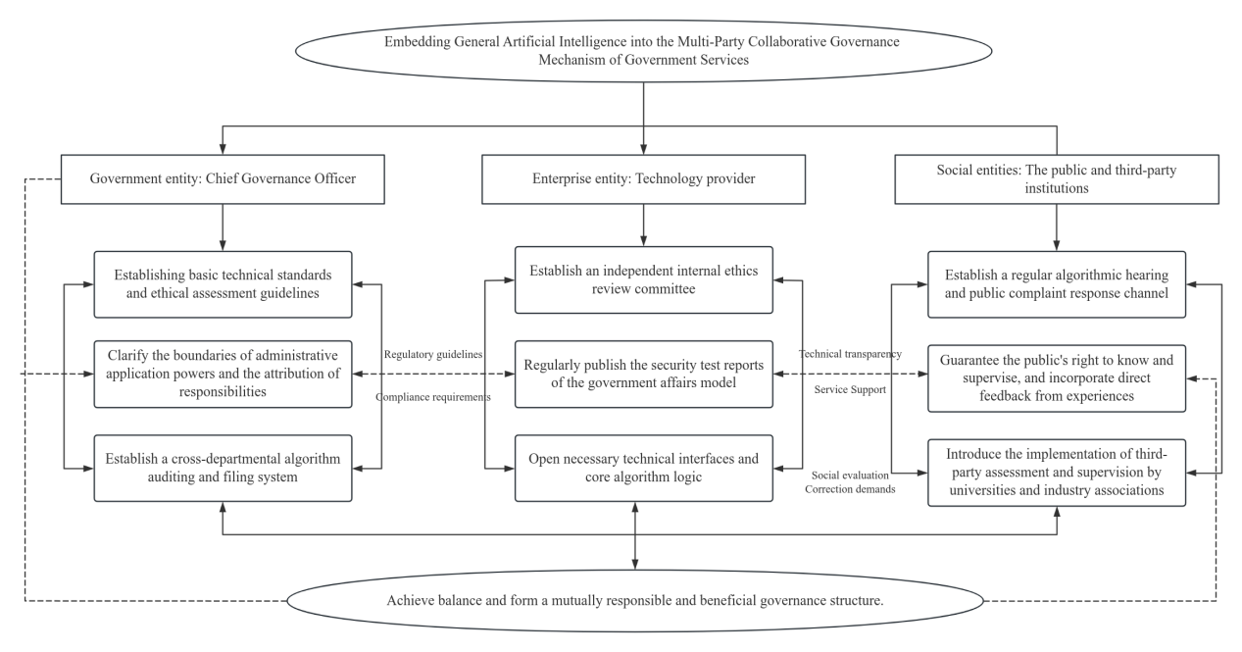
Figure 3: Multi-party collaborative mechanism involving the government, enterprises, and society

3.3 Agile Institutional Innovation and Regulatory Feedback Mechanism
Agile governance emphasizes the flexibility, adaptability, and forward-looking nature of public policies. It seeks to find the balance between technological development and security control through a dynamic game of error tolerance and correction. From the perspective of institutional innovation, administrative entities should actively introduce a restricted real testing environment mechanism to leave a controllable operating space for the still immature general government models. Within a specific testing area, the government can conduct empirical observations on the social risks, system logical flaws, and ethical conflicts existing in intelligent government applications, thereby providing real and specific administrative feedback for improving regulatory policies without causing risks to spread throughout the entire society. Correspondingly, the regulatory system needs to shift from the original single post-event punishment to a dynamic feedback throughout the entire life cycle. This means that the government should use monitoring platforms and automated evaluation tools to immediately track the operational status of government service algorithms after their practical application. When the system experiences bias deviation, decision failure, or causes serious factual errors during complex interaction processes, immediate graded and classified intervention measures should be taken, including downgrading operation, manual takeover, or termination of operation.

Conclusion
The deep integration of general artificial intelligence into government services not only enhances administrative efficiency but also gives rise to extremely serious ethical risks, such as algorithmic black boxes, entrenched biases, and shifting accountability, profoundly impacting traditional procedural justice and accountability systems. To solve this complex crisis, it is necessary to abandon individual regulations and instead focus on strengthening endogenous technical regulations, deepening the collaborative efforts of multiple entities, including the government, enterprises, and society, and complementing this with agile and dynamic regulatory feedback. This is required to achieve a dynamic balance between technological empowerment and public interests.

References
[1]Nascimento M V P, Siqueira D B B P, Chrispim N, et al. The future of AI in government services and global risks: insights from design fictions[J].European Journal of Futures Research,2025,13(1):9-9.
[2]Nawafleh S, Rawabdeh I, Qaoud A G, et al. E-governance and AI impact on the improvement of e-government services: transformative leadership as a mediator[J].International Journal of Electronic Governance,2025,17(1):25-50.
[3]Khalifa A. M. S A Opportunities, challenges, and benefits of AI innovation in government services: a review[J]. Discover Artificial Intelligence,2024,4(1).
[4]Abdulaziz A, Kailash K. Use of artificial intelligence to enhance e-government services[J].Measurement: Sensors,2022,24.
[5]Chohan R S, Akhter H Z. Electronic government services value creation from artificial intelligence: AI-based e-government services for Pakistan[J].Electronic Government, an International Journal,2021,17(3):374-390.

